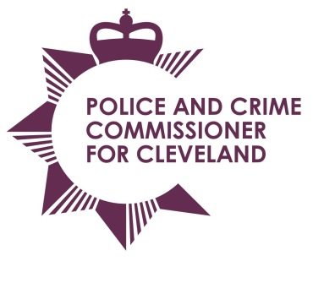
Police & Crime Commissioner for Cleveland
Cleveland Police Headquarters
Ladgate Lane
Middlesbrough
TS8 9EH

Email: pcc@cleveland.pnn.police.uk
Website: http://www.cleveland.pcc.police.uk

Police and Crime Commissioner: Barry Coppinger Tel: 01642 301653
Chief Executive & Monitoring Officer: Simon Dennis BA, Solicitor Tel: 01642 301653
Chief Constable: Iain Spittal Tel: 01642 301217

Working Together
(Working Together to Make Cleveland Safer and Securing the Future of Our Communities)

Date: Thursday 8 September 2016
Time: 10am – 12 noon
Venue: PCC’s conference room, Ladgate Lane

Agenda

 | Apologies For Absence
 | Declaration of conflict of interest/disclosable pecuniary interest
Introduction from PCC
- New Police and Crime Plan
- New Commissioning and Scrutiny programmes
 | Notes of the previous meeting
 | Prevent – (National Strategic Policing Requirement - local context)  - Cyber-crime  - Cleveland Connected  - E-Cins | Discussions
 | Commissioned Services | J Hodgkinson
 | Local Criminal Justice Board  - Reducing Reoffending subgroup  - Strategic Victims Group report | J Hodgkinson
 | Forward Plan with Key Events | For information
 | Any Other Business
 | Date of next meeting – 7 December 2016

