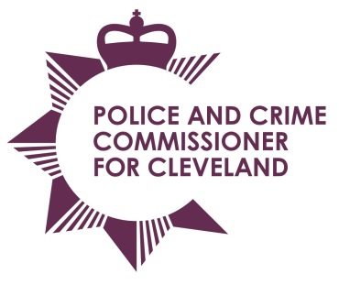
Police & Crime Commissioner for Cleveland
Cleveland Police Headquarters
Ladgate Lane
Middlesbrough
TS8 9EH

Email: pcc@cleveland.pnn.police.uk
Website: http://www.cleveland.pcc.police.uk

Police and Crime Commissioner: Barry Coppinger Tel: 01642 301653
Chief Executive & Monitoring Officer: Simon Dennis BA, Solicitor Tel: 01642 301653

PCC Scrutiny, Delivery & Performance Meeting

Date: 31 January 2017
Time: 11am – 1pm
Venue: PCC conference room
Agenda

 |  | Presented by
 | Apologies For Absence
 | Declaration of conflict of interest/disclosable pecuniary interest
 | PCC Scrutiny questions
 | Forward Plan
 | Date of next meeting – Wednesday 12 July 2017 | To agree

