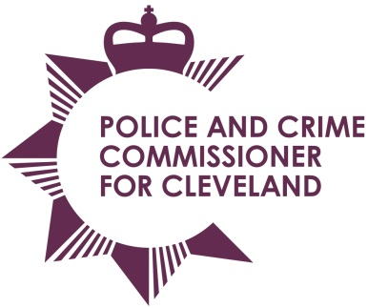
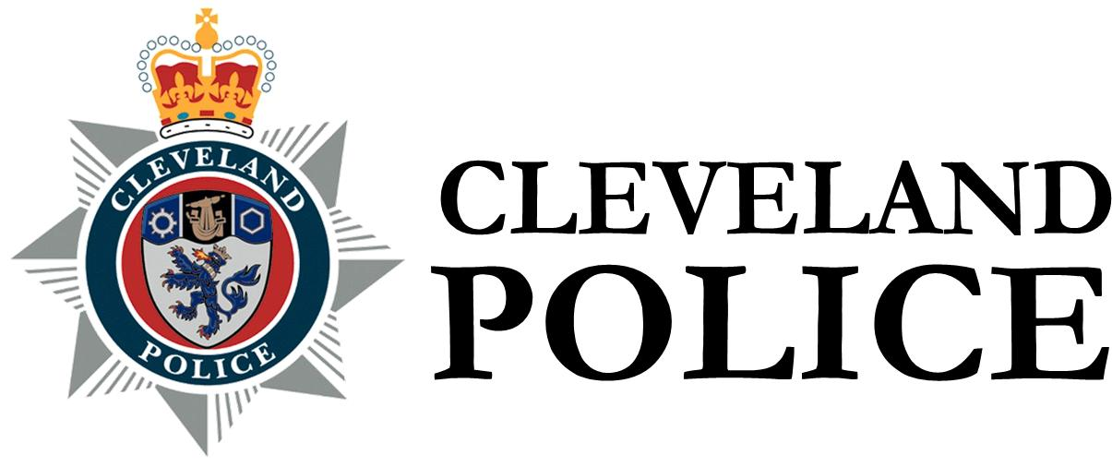

Joint Cleveland Audit Committee

Date: Thursday 17th December 2015
Time: Meeting Starts 10.30am
Audit Committee to meet at 9.45am

Venue: PCC Conference Room, Police Headquarters, Ladgate Lane

1. Apologies for absence
2. Declarations of interests
3. Open Minutes of the previous meeting held on 24 September 2015 | 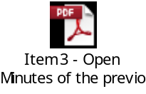
4. Professional Standards Update – Report of the Chief Constable | 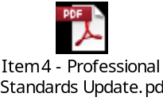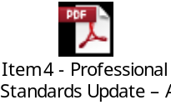
5. Information Security Update – Report of the Chief Constable | 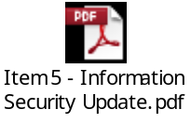
6. Annual Governance Statement 2014/15 Update – Report of the Chief Constable | 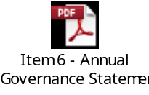
7. Annual Governance Statement 2014/15 Update – Report of the PCC | 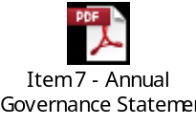
8. Cleveland Police Ethics Committees – Report of the Chief Constable | 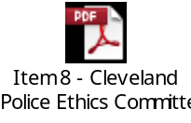
9 Annual Audit Letter – Chief Constable – Report of the External Audit | 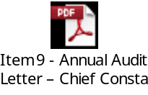
10. Annual Audit Letter – PCC – Report of the External Audit | 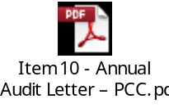
11. Progress Report – Report of the Internal Audit | 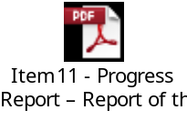
12. Grants – Report of the Internal Audit | 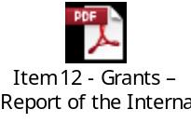
13. Cyber Crime Governance – Report of the Internal Audit | 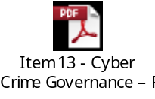
14. Collaboration – Evolve & Shared CFO Arrangements – Report of the Internal Audit | Verbal Update
15. Collaborations - Force Report – Report of the Internal Audit | 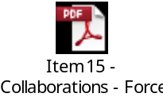
16. Proceeds of Crime – Report of the Internal Audit | 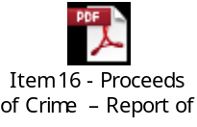
17. Quarter 2 Spot Checks Crime & Property – Report of the Internal Audit | Verbal Update
18. To consider passing a resolution pursuant to Section 100A (4) of the Local
Government Act 1972, excluding the Press and Public from the meeting under Paragraph 7 of Part 1 of Schedule 12A to the Act
19. Closed Minutes of the previous meeting held on 24 September 2015
20. Strategic Risk Management & Service Continuity Planning – Report of the Chief Constable

To: The Chair and Members of Joint Cleveland Audit Committee

Mrs Ann O’Hanlon (Chair) Mr Stan Irwin (Vice Chair)
Mr Aslam Hanif Mr Roman Pronyszyn

Mr Gerard Walsh

