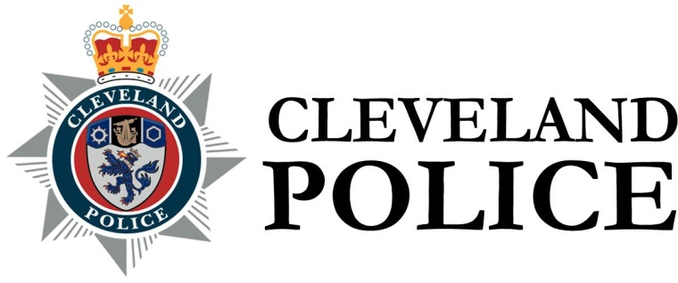
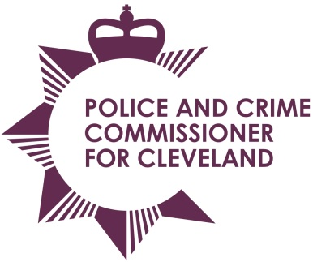

Joint Cleveland Audit Committee

Date: Thursday 24th March 2016
Time: 10.00 am – Audit Committee to meet at 9.15 am
Venue: Netherby Suite – Middlesbrough Golf Centre

AGENDA

- Apologies for absence
- Declarations of interests
- Open Minutes of the previous meeting held on 17th December 2015
- Civil Claim Statistics – Report of the Chief Constable
- Strategic Risk Register– Report of the PCC
- Contract Standing Order 9 – Exceptional Situations –
Report of the Chief Constable
- Draft Annual Governance Statement – Report of the Chief Constable
- Draft Annual Governance Statement – Report of the PCC
- Code of Corporate Governance Update – Report of the PCC
- Audit Strategic Memorandum – CC – Report of External Audit
- Audit Strategic Memorandum – OPCC – Report of External Audit
- Audit Progress Report – Report of External Audit
- Internal Audit and Inspection recommendations Update –
Report of the Chief Constable
- Progress Report – Report of Internal Audit
- Collaboration – Evolve and Shared CFO - Report of Internal Audit
- Quarter 2 Spot Checks – Cash and Property- Report of Internal Audit
- Key Financial Controls - Report of Internal Audit
- Risk Maturity - Report of Internal Audit
- Quarter 3 Spot Checks - Cash and Property - Report of Internal Audit
- Integrated Offender Management Report of Internal Audit
- Human Resources – Training - Report of Internal Audit
- Victim Referral Service - Report of Internal Audit
- Payroll and Expenses - Report of Internal Audit
- Follow Up Report - Report of Internal Audit
- Internal Audit Strategy 2015/2016 – 2018/19 -
Report of the Internal Audit
- Audit Committee Terms of Reference – Report of the PCC
- Audit Committee Schedule of Work and Meetings Schedule
– Report of the PCC

