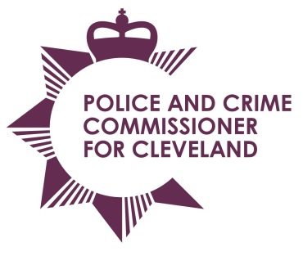
Police & Crime Commissioner for Cleveland
Cleveland Police Headquarters
Ladgate Lane
Middlesbrough
TS8 9EH

Email: pcc@cleveland.pnn.police.uk
Website: http://www.cleveland.pcc.police.uk

Police and Crime Commissioner: Barry Coppinger Tel: 01642 301653
Chief Executive & Monitoring Officer: Simon Dennis BA, Solicitor Tel: 01642 301653

PCC Scrutiny, Delivery & Performance Meeting

Date: Wednesday 30 November 2016
Time: 10am
Venue: PCC’s office
Agenda

 |  | Presented by
 | Apologies For Absence
 | Declaration of conflict of interest/disclosable pecuniary interest
 | Notes from previous meeting.
 | Management and Performance updates  - Revenue and Capital Budget monitoring  - Long Term Financial Plan update  - Sickness Monitoring report | OPCC  Cleveland Police
 | PCC Scrutiny questions
Other updates
- HMIC Stop & Search Review update (Cleveland Police update)
 | Forward Plan (for information only)
 | Any Other Business
 | Date of next meeting – Wednesday 7 December 2016

