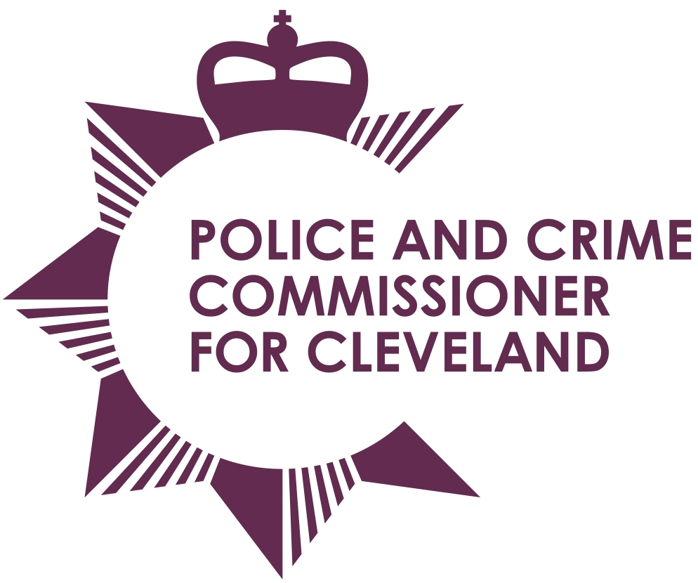
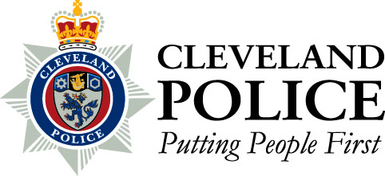

Joint Cleveland Audit Committee

Date: Thursday 16th May 2013

Time: 10.30am – Members to meet at 9.45am

Venue: Executive Conference Room, Police Headquarters, Ladgate Lane

AGENDA

1. | Apologies for absence
2. | Declarations of interests
3. | Open Minutes of the previous meeting held on 21st March 2013
4. | Governance – Post PCC Election Review – Report of the Internal Audit
5. | Compliance with Contract Standing Orders - Report of the Internal Audit
6. | District / BCUs - Report of the Internal Audit
7. | Progress Report - Report of the Internal Audit
8. | Draft Internal Audit Updated Strategy and Plan - Report of the Internal Audit

9. | To consider passing a resolution pursuant to Section 100A (4) of the Local Government Act 1972, excluding the Press and Public from the meeting under Paragraph 1 of Part 1 of Schedule 12A to the Act
10. | Closed Minutes of the previous meeting held on 21st March 2013 Chief Constable

To: The Chair and Members of Joint Cleveland Audit Committee

Mrs Ann O’Hanlon (Chair) Mr Stan Irwin (Vice Chair)
Mr Roman Pronyszyn Mr Gerard Walsh
Mr Aslam Hanif

