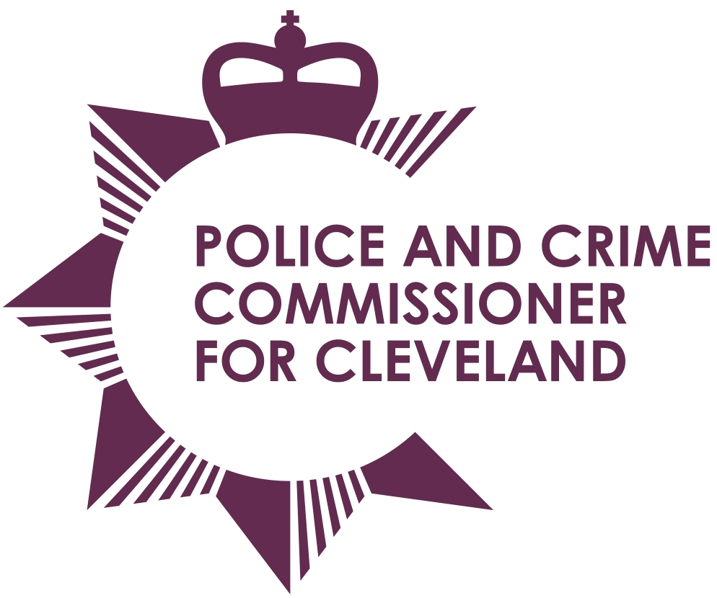
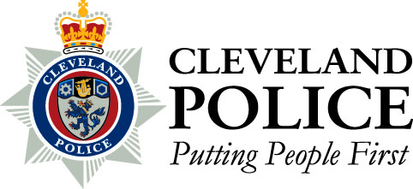

Joint Cleveland Audit Committee

Date: Thursday 19th December 2013
Time: 10.30am – Audit Committee to meet at 9.45am
Venue: The Education Centre, Junction Road, Norton, Stockton on Tees, TS20 1PR, Room J

AGENDA

- 1. | Apologies for absence
- 2. | Declarations of interests
- 3. | Open Minutes of the previous meeting held on 26th September 2013
- 4 | Professional Standards Update – Report of the Chief Constable
 | Progress Report – Report of the Internal Audit
- 5. | Risk Management – Report of the Internal Audit
 | Follow Up report – Steria Contract – Report of the Internal Audit
 | Payroll including Expenses – Report of the Internal Audit
 | Procurement – Report of the Internal Audit
 | Culture – Report of the Internal Audit
 | TOIL/RDIL– Report of the Internal Audit
 | Ordering, Receipt & Payments – Report of the Internal Audit
 | Procurement of Internal Audit Services (1st April 2014 – 31st March 2017) – Joint Report of the PCC and Chief Constable
 | Annual Audit Letter – Chief Constable – Report of the External Audit
 | Annual Audit Letter – PCC – Report of the External Audit
 | Annual Equality & Diversity Update – Report of the Chief Constable
 | Annual Governance Statement 2012/13 Update – Report of the PCC
 | Annual Governance Statement 2012/13 Update– Report of the Chief Constable
 | Committee Schedule of Work and Meeting Schedule – Report of the PCC
- 14. | To consider passing a resolution pursuant to Section 100A (4) of the Local Government Act 1972, excluding the Press and Public from the meeting under Paragraph 3 and 7 of Part 1 of Schedule 12A to the Act
- 15. | Closed Minutes of the previous meeting held on 26th September 2013
 | Strategic Risk Management and Service Continuity Planning – Report of the Chief Constable

To: The Chair and Members of Joint Cleveland Audit Committee

Mrs Ann O’Hanlon (Chair) Mr Stan Irwin (Vice Chair)
Mr Aslam Hanif Mr Roman Pronyszyn

Mr Gerard Walsh

