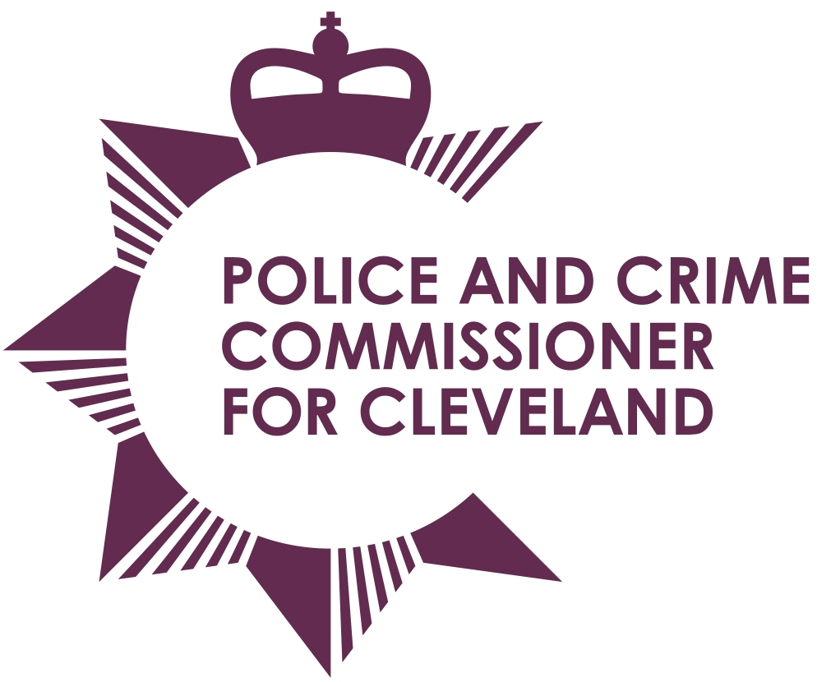
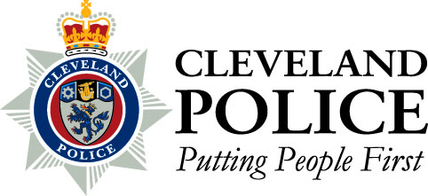

Joint Cleveland Audit Committee

Date: Thursday 26th September 2013

Time: 10.30am – Audit Committee to meet at 9.45am

Venue: Middlesbrough Teaching & Learning Centre, Cargo Fleet Lane, Middlesbrough

AGENDA

- 1. | Apologies For Absence
- 2. | Declarations Of Interests
- 3. | Open Minutes of the Previous Meeting Held on 27th June 2013
- 4 | Civil Claim Statistics – Report of the Chief Constable
- 5. | Contract Standing Order No. 9 – Exceptional Situations – Report of the Chief Constable
 | Progress Report - Report of Internal Audit
- 6. | Attendance Management – Report of the Internal Audit
- 7. | VAT – Report of Internal Audit
 | Additional Payments - Report of Internal Audit
 | Financial Planning - Report of Internal Audit
 | Internal Audit Recommendations Implementation Update – Report of the Chief Constable
- 9. | Audited Statement Of Accounts – Report of the PCC
- 10. | Audit Completion Report – Report of the External Audit
- 13. | Strategic Risk Register – Report of the PCC
 | Report Of The Monitoring Officer (November 2012 – March 2013) – Report of the PCC
- 14. | To Consider Passing A Resolution Pursuant To Section 100A (4) Of The Local Government Act 1972, Excluding The Press And Public From The Meeting Under Paragraph 3 And 7 Of Part 1 Of Schedule 12A To The Act
- 15. | Closed Minutes Of The Previous Meeting Held On 27 June 2013
 | Contract Standing Order No. 9 – Exceptional Situations – Report of the Chief Constable

To: The Chair and Members of Joint Cleveland Audit Committee

Mrs Ann O’Hanlon (Chair) Mr Stan Irwin (Vice Chair)
Mr Aslam Hanif Mr Roman Pronyszyn

Mr Gerard Walsh

