Police and Crime Plan 2021-24 – Public Consultation Results (Summer 2021)

Background
PCCs are elected by the public to hold Chief Constables and the Force to account, effectively making the police answerable to the communities they serve. A key role for PCCs is representing and engaging with local communities to help deliver their policing priorities. The PCC produces a Police and Crime Plan covering their term of office that sets out the priorities for local policing for the whole force area, and how they are going to be addressed. This document sets out the PCC's objectives for policing and reducing crime and disorder in the area, how policing resources will be allocated, agreements for funding and performance reporting requirements.

On 6th July the PCC presented his draft Police and Crime Plan to the Police and Crime Panel, setting out 10 clear objectives for his 3 year term of office.
- More police on the streets
- Effective support for victims and witnesses of crime
- Bringing offenders to justice
- Getting tough on drugs and gangs
- Tackling antisocial behaviour head on
- Preventing, tackling and reducing serious violence
- Using technology to combat crime
- Building confidence in Cleveland’s communities
- Tackling violence against women and girls
- Ensuring an effective policing and criminal justice system
An online public consultation was launched on 8th July to inform the final version of the Plan which will go to the Police and Crime Panel for approval on 14th September.

The consultation ran until Monday 23rd August and was promoted through OPCC social media and press releases, together with linking in to key community safety partner organisations. In addition to the online survey OPCC staff attended a range of community events across Cleveland with paper copies of the survey to ensure a wider representation of views were included in the consultation. Roadshows were held at the following events:
- Loftus Community Fayre
- Middlesbrough Mela
- Hartlepool Middleton Grange shopping centre
- Redcar market
- Stockton market
- Thornaby market
- Billingham market

Specific workshops were also undertaken with young people, older people and the hearing impaired community.

The OPCC commissioned VCSE organisation Skills for People, who work with the learning disabled community, to produce an Easy Read version of the survey for consultation with their service users and the wider learning disabled community.
Results

Demographics
In total 560 responses were received to the consultation. The survey was open to residents, businesses and people working for community safety partner organisations. The majority of respondents (93.5%) were residents, with a small number of responses received from local businesses (2.5%) and community safety partner organisations (1.5%).

Responses were spread across the whole of Cleveland with 34% from Stockton, 26.5% from Redcar and Cleveland, 19% from Hartlepool and 15.5% from Middlesbrough. 4.5% of respondents stated that they were Cleveland wide.

The majority of respondents (95.7%) identified as White British. There were a small number of responses from other white backgrounds (8), Pakistani (5), Mixed backgrounds (11) and 1 Black Caribbean respondent. The remaining respondents preferred not to disclose their ethnicity.

Females were more likely to complete the survey than males – 53.5% compared to 41.7%. There were a small number of respondents from people who identified as non binary (6). The remaining respondents stated Other or prefer not to say.

13% of respondents classed themselves as having a disability.

Whilst responses were spread across all age groups nearly half the respondents (45%) were aged between 45 and 64. The chart below shows the full range of age responses received.

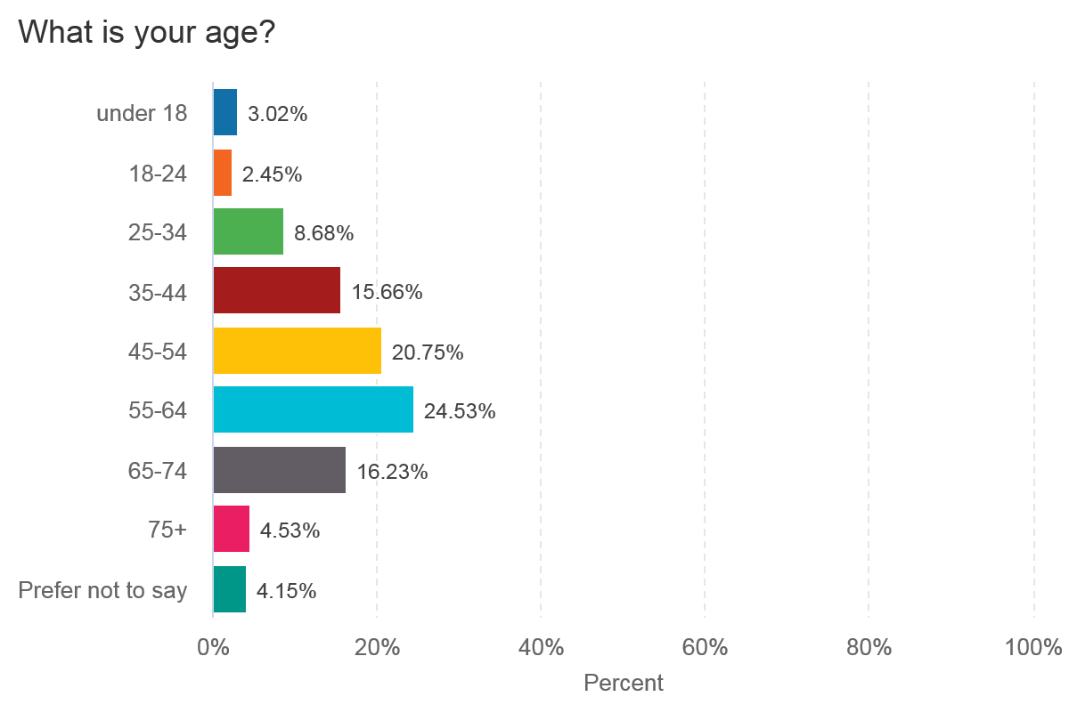
Police and Crime Plan Priorities
Respondents were asked how important they felt each of the 10 priorities in the plan were, with options of:
- Very important
- Important
- No opinion
- Not very important
- Not at all important

The majority of respondents felt that all of the priorities were important. The highest priority, both in terms of percentage of ‘very important’ responses and combined percentage of ‘very important’ and ‘important’ responses was ‘Bringing offenders to justice’. Using the same analysis the lowest priority was ‘Using technology to combat crime’ although 49.27% of respondents felt this was ‘very important’ and 34.18% felt it was ‘important’ so there was still 83.45% support for the priority.

The table below ranks the priorities in terms of the percentage of respondents who felt the priority was ‘very important’:

Priority | Very Important (%) | Important (%)
Bringing offenders to justice | 86.69 | 11.33
Getting tough on drugs and gangs | 81.6 | 14.94
Tackling antisocial behaviour head on | 77.84 | 18.02
Effective policing and criminal justice system | 77.34 | 20.06
Prevent, reduce and tackle serious violence | 76.90 | 20.58
More police on our streets | 75.31 | 20.04
Tackling violence against women and girls | 72.36 | 22.00
Building confidence in our communities | 66.18 | 27.09
Effective, quality support to victims and witnesses of crime | 56.76 | 36.04
Use technology to combat crime | 49.27 | 34.18

The consultation then went on to ask respondents what activity they felt was needed to deliver each priority.

Bringing Offenders to Justice
By far the most common suggestion for this priority was to campaign for harsher punishments for offenders. Many people felt that the criminal justice system was out of touch with local communities and that sentences did not fit the crimes being committed. A lot of respondents felt that the behaviour of young people was particularly problematic with offending having to hit too high a threshold before sanctions were put in place.

It was also felt that the criminal justice process needed to be more timely, with the length of time between offending and going to court being excessively long leading to additional stress on victims and witnesses and an increased witness attrition rate. Having dedicated staff to support victims and witnesses through the process was seen as key.

An increase in visible policing, together with more robust investigations, with staff having better investigative training was seen as important. Increased CCTV was seen as a good method of achieving better evidence to bring offenders to justice, and an increase in the use of stop and search as a preventative tool was advocated.

Many respondents recognised the value of education to prevent offending and rehabilitation to deter re-offending. There was considerable support for Restorative Practice, both in terms of the impact on reoffending rates but also in terms of victims satisfaction and closure.

Some practical process changes were suggested by police officers who completed the survey, including:
- Officers to attend burglaries and other volume crime where crime series affects numerous victims and one offender being brought to justice would benefit numerous victims.
- Re-establish Drug Unit to target those most serious drug dealers.
- Keep prisoners on remand until sentencing to avoid further offending.
- More back office support to allow front line officers to focus on front line duties.
- More designated powers to PCSOs to allow them to deal with minor crimes.
- Training for judges and magistrates to ensure they appreciate public opinion and perceptions around crime types and sentence accordingly within the sentencing guidelines.

Getting Tough on Drugs and Gangs
Many of the responses regarding this priority mirrored the responses to the ‘Bringing Offenders to Justice’ priority, with calls for tougher sentences for offenders, increased police presence, greater use of stop and search, increased powers for PCSOs and more robust enforcement activity, especially around timeliness of acting upon intelligence and seizure of criminal assets.

The reinstatement of a Cleveland Police dedicated drugs team was very much supported, with some suggestions that this could work either jointly to tackle gangs or in conjunction with a dedicated gangs team.

Building the trust of the local community to share information and intelligence on drug dealers and gangs was seen as crucial in achieving this priority. There were several suggestions regarding how to facilitate reporting including developing an app to report drug houses, a dedicated drug information contact number and more possibilities for anonymous reporting or for evidence to be used anonymously in criminal prosecutions. Providing feedback to people who have reported was also seen as key in developing community confidence and trust and encouraging further reporting.

Education to prevent young people becoming involved in drugs and gangs was supported, together with more diversionary activities for young people. Improved drug treatment and rehabilitation services were also suggested, with many emphasising the importance of providing support to drug users to understand the reasons behind addiction and change behaviour.

Increased drug testing, both in work places and also through Roads Policing was suggested.

Several respondents felt that the PCC should lobby for a change in centralised drug policy, and that some drugs should be legalised.

Tackling Antisocial Behaviour Head On
By far the most common suggestion for this priority was increased visible police presence, with officers ring fenced to specific areas to allow them to gain an understanding of the local community issues and build trust and confidence with residents. It was felt that currently neighbourhood teams are acting as second tier response so should be given the time to be dedicated neighbourhood resources. There were also some calls to re-establish the Ward Support Team as an additional resource to tackle neighbourhood issues such as antisocial behaviour.

Harsher punishments for offenders were also advocated. Many respondents felt that there were no consequences for young people behaving antisocially leading to behaviour becoming entrenched before it was robustly challenged. Lack of parental responsibility was frequently mentioned with many respondents feeling that parents should be held more accountable for the actions of their children.

A greater focus on early intervention was suggested, with increased education and use of community reparation and restorative justice, together with more diversionary activities available for young people. The creation of Youth Zones in other areas of the country was highlighted as best practice.

Many people felt that increased CCTV would assist in both deterring offenders and in gathering evidence to assist with prosecutions.

Easier reporting mechanisms was also suggested with many citing issues with the non emergency 101 number.

Effective Policing and Criminal Justice System
Again a common suggestion for this priority was increased police resources, both front line staff but also back office analytical staff to ensure resources are appropriately targeted and use of evidence based practice is maximised. Increased use of CCTV and stop and search were also suggested as ways of improving the effectiveness of local policing.

Many respondents felt that the current criminal justice system needs an overhaul, with sentencing guidelines that reflect modern crimes and public perceptions. It was felt that judges should receive additional training to better appreciate public opinion, with many feeling that a large proportion of judges were out of touch with the local community.

A more streamlined, less bureaucratic criminal justice system was also advocated. The current system is seen to place too much of a bureaucratic burden on front line police officers in terms of paperwork – there were some calls for increased support for front line staff through a better resourced Criminal Justice Unit. Improved joined up working between the Police and CPS was also suggested with many feeling that CPS priorities did not match the priorities of the police.

It was felt that measures could be taken to make it easier for victims to go through the criminal justice process – allowing victims to give evidence anonymously would improve support from the community in taking forward prosecutions as many fear retribution from offenders. The increased use of remote video links to give evidence was also supported.

Several respondents also advocated increased support for offenders leaving prison to deter re-offending and also greater links between education and the criminal justice system to deter offending behaviour in the first place.

Prevent, Reduce and Tackle Serious Violence
Again a common suggestion for this priority was increased police resources, with improved shift patterns designed to cover peak times and areas of demand. A more timely and more robust response to reports was also advocated, with harsher punishments for offenders.

Many respondents noted the links between serious violence and domestic abuse, with suggestions that domestic abuse should be treated more seriously and that young people exposed to domestic abuse should be given appropriate support.

The link between drug and alcohol use and serious violence was also noted, with many respondents feeling that more robust enforcement in these areas would lead to a reduction in serious violence.

Increased education was suggested, both in terms of young people, but also parental and community awareness. This should be accompanied by increased use of early intervention measures, and work with offenders to target the causes of criminality.

Better support for victims and witnesses going through the criminal justice process was suggested, together with increased use of Restorative Justice.

More use of stop and search, increased CCTV coverage and use of drones were suggested, together with a focus on evidence led prosecutions for violence offences being considered more widely than simply for domestic abuse. Increased opportunities to report anonymously were also supported.

The creation of a multi agency Violence Reduction Unit using a public health approach to tackle serious violence was advocated by several respondents.

Some concerns were raised in terms of officer safety tackling increasing levels of violence with calls for more officers to be equipped with tasers and for double crewing to be mandated.

More Police on our Streets
Respondents felt that a key focus for the PCC for this priority is to lobby central government for more funding for policing. Increased recruitment of Special Constables, a reduction in senior management and a reduction in uniformed staff in back office roles were also suggested.

Having dedicated, ring fenced neighbourhood resources was seen as key, both in terms of deterring crime and also building public confidence to report information and intelligence.

Better support for existing officers was also mentioned, specifically having experienced mentors for new recruits, effective trauma support counselling and a shift pattern that enabled officers to cover peak demand periods whilst also maintaining an effective work life balance.

Many respondents felt that re-opening facilities or reinstating departments would help – opening police stations to allow face to face reporting, opening Hartlepool Magistrates Court and custody suite, and reinstating the Police Mounted section.

Increased usage of drones and CCTV to facilitate information and evidence gathering was advocated, together with harsher punishments for offenders keeping repeat offenders off the streets.

Tackling Violence Against Women and Girls
Many respondents felt that this priority should be reworded to have a focus on both violence against males and females.

Education in schools was seen as key, particularly around what constitutes a healthy relationship and consent. Many people felt that women should be taught self defence from a young age.

More promotion of available support services was suggested, together with increased officer training, particularly around coercive and controlling behaviour.

Better street lighting and increased partnership working and awareness raising with Night Time Economy staff was seen as beneficial, together with mandatory perpetrator programmes for offenders.

As in previous priorities respondents also felt that more visible policing and increased use of CCTV would be beneficial.

Building Confidence in our Communities
Respondents felt that the key activity needed to deliver this priority was an increased, visible police presence in local communities, with dedicated officers for each area who engage and speak to local residents to build relationships. Having a dialogue with community groups and leaders was seen as fundamental to this approach. Several respondents suggested re-opening police stations to the public, or having front line officers available to speak to in community hub locations. It was also felt that crimes such as burglaries should receive a face to face response and not be dealt with over the phone.

Regular visits from the police to schools was seen as a beneficial activity and many respondents also felt that senior police leaders should spend more time in local communities engaging with local people.

Regular feedback and updates to those reporting crimes and incidents was seen as really important, together with having an effective reporting mechanism. Many felt that the 101 non emergency number was not fit for purpose and there was support for the development of an app to facilitate non emergency reporting.

Improved communications around police activity was suggested with many stating that the police undertake a lot of good work which the community are largely unaware of.

Improved support for Neighbourhood Watch was also advocated.

Effective, Quality Support to Victims and Witnesses of Crime
Respondents felt that victims reporting crime expected a timely face to face response from the police. It was felt that officers should be given the time to engage effectively with victims and obtain information, rather than having to dash off to the next job on the queue. Many respondents felt that officers would benefit from additional training, especially around understanding victim’s mental health needs. Empathetic police officers were key to maintaining victim confidence.

Regular updates to victims were seen as crucial in keeping them engaged in investigations and maintaining confidence – one officer suggested having an automated system to remind officers when Victims Code of Practice updates were due, or having civilian staff to feed back to victims on the progress of their case. Having a Single Point of Contact for victims to go to for updates was also suggested.

Several victims reported feeling frustrated at lack of progress in their cases due to staff abstractions and it was felt that there should be a handover process if an officer is going to be away from work for a considerable period of time.

There was little awareness in the community of current support services available for victims, so many respondents suggested these should be more widely promoted, and also expanded to provide 24 hour support through a dedicated phone line and online support. Having dedicated one to one support through the criminal justice process was seen as very beneficial.

In terms of attending court, it was suggested that witnesses should be kept completely separate from offenders and their families and that opportunities for giving evidence anonymously should be explored.

Use Technology to Combat Crime
The keys areas of technology mentioned for this priority were increased use of drones, CCTV and tagging together with the development of an app to report crime.

Increased use of social media to promote the activity police are currently undertaking and to offer crime prevention tips and advice was also suggested. Many felt that the police should also more actively monitor social media posts to assess tensions and threats in communities.

Many respondents felt that all police officers should have access to body worn video for evidential and safety purposes.

Officers felt that they were not always able to access the best technology to do their jobs effectively. This has been particularly apparent during the pandemic with lack of sufficient access to remote technology. It was felt that technical projects within the police would be better managed by externally recruited technical specialists rather than internal police staff.

Other Areas of Focus
Respondents were asked if they felt anything was missing form the stated priorities – the key areas people felt were not picked up in the stated priorities were hate crime, roads policing and rural crime.

Young People
A specific consultation was undertaken with young people through a discussion with the OPCC Youth Commission, whose members are between the ages of 14 and 25.

Tackling violence against women and girls was seen as particularly important by this group – the murder of Sarah Everard had provoked a lot of debate on this subject and many young women reported that they and their friends often felt unsafe and threatened by male behaviour.

Building confidence in our communities was also an important area for the young people consulted – they felt more work needed to be done to build relationships between the police and young people, with increased work in schools, more information on the work the police do and use of young person friendly social media such as TikTok advocated. An increased visible police presence was also supported as a means of building confidence.

The priority to prevent, reduce and tackle serious violence also provoked some discussions with young people suggesting more knife amnesty bins and education around the consequences of violent crime through victim accounts.

The group felt that the existing priorities lacked a focus on preventative and rehabilitative work to deter offending and prevent re-offending. Education with young people on the consequences of crime was seen as important, together with work with offenders to understand the root causes of offending and put in place effective support.

Older People
Engagement was conducted with older people through focus groups with Age UK service users. Service users also completed surveys which were fed into the wider consultation.

This age group was particularly supportive of a return to dedicated neighbourhood policing, with an increased visible police presence in communities and more face to face contact with communities and victims. Closure of local satellite police stations was viewed particularly negatively by this group, who felt it alienated local communities. They were also particularly supportive of harsher punishments for offenders.

Hearing Impaired Community
A focus group was held with the Hartlepool Deaf Club who support the deaf and hearing impaired community of Hartlepool and the wider Cleveland area.

A key theme from this group was the need for enhanced communication between the police and the hearing impaired community. There is currently no effective mechanism for people who are deaf from birth to report crime, as for many British Sign Language is their first language and they do not understand written English meaning online reporting is not accessible to them. The Control Room also currently has no videophone technology so many community members rely on family of friends to report incidents on their behalf. Lack of timely access to BSL interpreters when reporting was also mentioned.

In terms of particular crime types, community members were especially concerned by drug dealing, antisocial behaviour and cycling on pavements which is particularly dangerous for this community who will not hear people approaching them from behind.

Special Needs Community
Skills For People (SFP) are a VCSE organisation who provide support for people with learning disabilities. The OPCC commissioned SFP to provide an easy read version of the consultation and to undertake specific work with service users to obtain their feedback on the suggested priorities.

20 service users gave their feedback on the proposed priorities, which they all felt were important. More police on the streets was the key priority for these participants.

Key themes to come out of discussions was the need for greater engagement between the police and people with learning disabilities and better understanding of how crimes can impact on this vulnerable group. Many felt they were not taken seriously when reporting crime due to their learning disability.

They felt that increased visibility of police would improve their confidence in approaching the police and reporting incidents, with several stating they would be nervous to approach a police officer. Engagement with community based PCSOs was really supported, with participants stating that when local PCSOs visited their groups it greatly increased their confidence.

Response times were particularly important to this group who expected a prompt response when reporting – “it takes ages – it needs to be quicker”. Easier reporting methods were also advocated, with many stating 101 took too long to respond.

Education with young people was seen as key in tackling drugs. In terms of violent crime the group felt more needed to be done to prevent young people buying knives.

As for the wider consultation, this group felt street lighting was really important in reducing violence against women and girls. They also felt it was crucial that women were believed and supported when reporting incidents.

In terms of what might be missing from the priorities the key theme mentioned was hate crime – participants felt that the police needed more training to understand the impact of hate crime on victims, and also how to deal with people with learning disabilities or autism sensitively. They also felt more support was needed for victims with learning disabilities or autism going through the criminal justice process.

Conclusion
Several key themes were picked up through the consultation, the main one being support for more visible policing, with dedicated neighbourhood teams for each area who were given the time to effectively engage and build relationships with local communities.

Lobbying for more funding from central government for policing and also for reforms to the criminal justice process with harsher sentences and increased training for judges and magistrates so they better understand local communities were also supported.

Easier reporting methods, increased usage of CCTV and better feedback to victims were also advocated.

In terms of areas that were missing from the existing priorities, the consultation suggested that a greater focus on preventative and rehabilitative work to deter offending and prevent re-offending was needed, together with specific focus on hate crime, rural crime and improved roads policing.

Several key suggested areas for operational change were also picked up, although these would be outside of the remit of the PCC and would be a decision for the Chief Constable – these included reinstating a dedicated Drugs Unit, more use of stop and search and increased powers for PCSOs.

