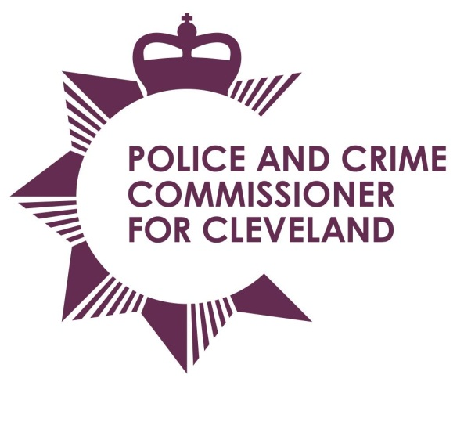
Fund Application Form
Project/Initiative Title:
Author:
Date:
Please tick
Application for Grant Funding
Application for Property Act Funding
[must be for charitable and non-policing activities and events]
Application for Community Safety Initiative funding

Completed forms should be emailed to pcc@cleveland.pnn.police.uk
Details provided within this application form will published on the PCC website at www.cleveland.pcc.police.uk

Section 1 – Basic bid information
Contact details
Please make sure that this person knows all aspects of your project and is able to talk about it if required.
Title: |  | First Name: |  | Last name:

Role/Position in organisation:

Organisation Name:
Organisation Address:

Postcode:
Telephone:

Email address:

Website:
In case of a joint bid, please list all organisations and agencies involved.
Organisation Name | Organisation Address | Contact name and details
How would you best describe your organisation?
Registered Charity |  |  | Registration Number:
Voluntary or community organisation/group
Self-help group/forum
Company limited by guarantee
Social Enterprise
Local Authority
Other |  |  |  | If other, please specify:
Aims and objectives of your organisation(s)
Please provide a summary of your organisation(s) aims and objectives (in no more than 300 words).

Section 2 – Strategy Statement
Brief description of proposed initiative or service (in no more than 300 words).
Which geographical area(s) will benefit most from your initiative for which this application relates. (Please tick all boxes which apply)
Redcar and Cleveland Stockton-On-Tees
Middlesbrough Hartlepool
Stakeholders
Who will benefit from the proposed initiative or service (in no more than 300 words).
Will this application support or enhance other services that you intend to commission? (in no more than 300 words?

Section 3 – Financial information
Funding requested
(Total funding requested)
Funding period and payment schedule
Payment schedule (single payment, quarterly etc)
Bid elements
Service/Initiative | Amount requested
 | £
 | £
 | £
 | £
Total funded requested | £
Joint bid elements (if applicable)
Service/Initiative | Amount requested
 | £
 | £
 | £
 | £
Total funded requested | £

Start and End Dates
Exit Strategy – Can you secure alternative funding or to have plans to scale down your proposal if required? (in no more than 300 words)

Section 4 – Meeting the Police and Crime Commissioner’s Objectives
Which of the following Police and Crime Plan objectives will your initiative contribute towards?
Investing in Our Police
A Better Deal for Victims
Tackling Re-Offending
Working Together to Make Cleveland Safer
Securing the Future of Our Communities

Please summarise how the initiative(s) will contribute towards the above objective (in no more than 300 words)

Section 5 – Performance Criteria
What are the expected outcomes and performance measurement criteria to be used (including as appropriate indicators and trend analysis).
Indicator/Trend | Outcome expected

Section 6 – Governance, Reporting and Communications Plans
Please add details of your communications plan, showing how the initiative(s) will be communicated to stakeholders, service users and other partners (where appropriate) (in no more than 300 words).

Privacy Notice
The information you have supplied in this form will be used to process your grant application. In order to make a decision on your application, some of the de-personalised information provided may go into a public decision report. In addition, your application form may be shared with third parties and partner agencies who may be involved in the decision making process or whom can verify specific facts within your application.
We may be required to disclose information outside of the Office of the Police and Crime Commissioner for Cleveland to help prevent fraud, or if required to by law.
We may not be able to process your application if you do not provide all the requested information.
Successful applications will be retained for a maximum of 6 years (plus current year). Unsuccessful applications will be retained for 6 months from the date the applicant was notified. Information will be securely retained on the computer systems used by staff in the Office of the Police and Crime Commissioner.
I give the Office of the Police and Crime Commissioner permission to store the information provided within this application and to share this information with the recipients listed above, where there is a need to do so.
Print name: Date:
Transparency/Open Data
If your application is successful, general details of grants will be published on the Office of the Police and Crime Commissioner for Cleveland’s website: https://www.cleveland.pcc.police.uk/Decisions/Decisions-of-the-PCC.aspx. No personal information will be published.
Declaration
I certify that all the particulars given in the form are correct and that any grant money received from the Police and Crime Commissioner for Cleveland will be used for the purposes stated in this form. The Police and Crime Commissioner for Cleveland reserves the right to reclaim any grant not used for the purposes stated on this form.
I understand that the grant applied for is for this financial year only and that nay grant provided will not be provided on an on-going basis in future years.
I agree to provide a report detailing the outcomes of this project/activity (a form will be sent out for completion at the relevant time) if our application is successful and will acknowledge the Police and Crime Commissioner in any publicity relating to the project.
Please tick here to accept the above declaration:
Note: Your application will not be processed if this box is not checked.

