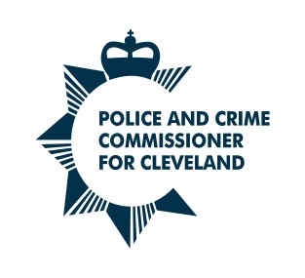
RESPONSE BY THE PCC TO
HMICFRS INSPECTIONS OF
CLEVELAND POLICE

INSPECTION DETAILS

Title of Inspection
PEEL 2021/22

Date Inspection Published
17 March 2023

Type of Inspection: Cleveland Specific National
Follow Up Thematic
Partner Inspection

Is Cleveland Police quoted in the Report? Yes No

EXECUTIVE SUMMARY OF REPORT

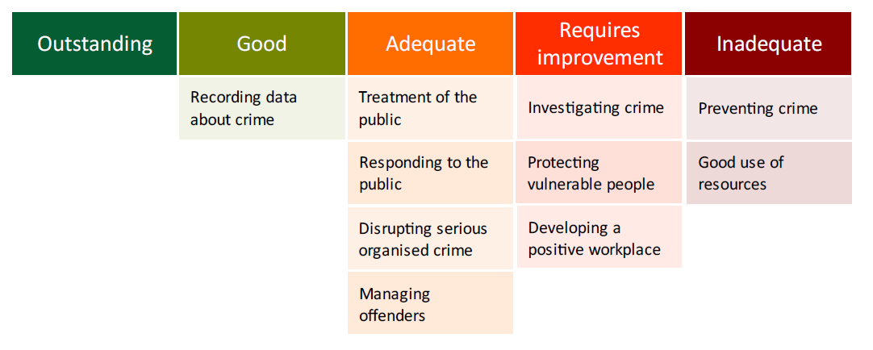
The HM Inspector observed that the force had faced numerous challenges which have caused its status to remain at ‘engage’ as part of their monitoring regime. This had included instability within the chief officer team and demand pressures.

The report noted that the force
- had significantly improved its crime recording
- improved its fair treatment of the public
- recognises vulnerability at first contact
- integrated an ethical culture
- it needs to review its neighbourhood policing resourcing and deployment model
- needs to get better at investigating reported crimes
- improve its understanding of hidden harm and work more closely with partner organisations
- developing how it plans and manages organisational efficiency

Causes of Concern and Areas for Improvement (AFI)

Engaging with and treating the public with fairness and respect (Adequate)
- The force needs to improve how it communicates with the public, making sure messages align with force and community priorities, and responses are monitored
- The force needs to improve how it involves the community in local policing activity

Preventing Crime and Anti-Social Behaviour (Inadequate)
Cause of Concern
The force hasn’t fully addressed the cause of concern about preventing crime and antisocial behaviour identified in the 2019 PEEL inspection Cleveland Police should take immediate steps to:
• provide strategic direction and co-ordination of all prevention activity;
• integrate preventative practice across the organisation and provide the capacity and capability to carry out structured problem-solving and prevention activity aligned with its priorities; and
• raise the organisational profile of evidence-based policing, thoroughly evaluate problem-orientated activity, and arrange the storage and sharing of good practice.

Responding to the Public (Adequate)
- The force needs to attend calls for service, particularly those involving vulnerable people, within its published time frames and should fully update victims when this doesn’t happen

Investigating Crime (requires Improvement)
- The force should make sure investigation plans are created where applicable, with supervisory oversight making sure that all investigative opportunities are taken and appropriate investigations are carried out
- The force needs to make sure that it complies with the requirements of the Code of Practice for Victims of Crime
- The force needs to improve its governance and monitoring processes to make sure that the use of outcomes is appropriate and complies with force and national policies

Protecting Vulnerable People (Requires Improvement)
- The force should improve its capability to identify hidden harm, particularly in instances where children go missing
- The force should improve the way it manages MARAC referrals and make sure safeguarding processes are properly risk assessed and approved at the appropriate level
- The force should improve how it shares safeguarding information with partner organisations

Managing Offenders and suspects (Adequate)
- The force should improve its use and ongoing management of bail and released under investigation
- The force should make sure that all indecent imagery of children investigations are risk assessed and regularly reassessed to check whether suspects have access to children and that action is taken to safeguard children

Building, supporting and protecting the workforce (Requires Improvement)
- The force should improve its understanding of workforce well-being with a specific focus on reducing officer sickness
- The force should improve its understanding of what factors influence recruitment and retention

Strategic Planning, Organisational Management and Value for Money (Inadequate)
Cause of Concern
The force hasn’t fully addressed the cause of concern relating to strategic planning, organisational management and value for money identified in its 2019 PEEL inspection Cleveland Police should continue to develop:
• its assessment of current and potential future demand across all operational areas to inform the force’s operating model. This should include latent demand and the demand generated by internal processes;
• co-ordinated financial and workforce plans based on demand, which should be integrated into the force's strategic planning cycle.

FORCE RESPONSE TO RECOMMENDATIONS
All new reports into the Force follow a specific process which involves holding a plenary session with relevant stakeholders to discuss the actions and agree how they will be progressed. The outcome from this session is reported to the Deputy Chief Constable for approval; progress is then monitored through governance meetings until such a time as the action is considered complete. The process for closing actions is depicted by HMICFRS, as they award each action a level; the Force complies with the appropriate course of action to request closure.

The Force has received and accepted the report and recommendations:

CoC 1 - The force hasn’t fully addressed the cause of concern about preventing crime and antisocial behaviour identified in the 2019 PEEL inspection.
Cleveland Police should:
- take immediate steps to provide strategic direction and co-ordination of all prevention activity
- take immediate steps to integrate preventative practice across the organisation and provide the capacity and capability to carry out structured problem-solving and prevention activity aligned with its priorities.
- take immediate steps to raise the organisational profile of evidence-based policing, thoroughly evaluate problem-orientated activity, and arrange the storage and sharing of good practice.

CoC 2 - The force hasn’t fully addressed the cause of concern relating to strategic planning, organisational management and value for money identified in its 2019 PEEL inspection.

Cleveland Police should
- continue to develop its assessment of current and potential future demand across all operational areas to inform the force’s operating model. This should include latent demand and the demand generated by internal processes.
- continue to develop co-ordinated financial and workforce plans based on demand, which should be integrated into the force's strategic planning cycle.

Recommendations

- The force needs to improve how it communicates with the public, making sure messages align with force and community priorities, and responses are monitored.
- The force needs to improve how it involves the community in local policing activity.
- The force needs to attend calls for service, particularly those involving vulnerable people, within its published time frames and should fully update victims when this doesn’t happen.
- The force should make sure investigation plans are created where applicable, with supervisory oversight making sure that all investigative opportunities are taken and appropriate investigations are carried out.
- The force needs to make sure that it complies with the requirements of the Code of Practice for Victims of Crime.
The force needs to improve its governance and monitoring processes to make sure that the use of outcomes is appropriate and complies with force and national policies.
- The force should improve its capability to identify hidden harm, particularly in instances where children go missing.
- The force should improve the way it manages MARAC referrals and make sure safeguarding processes are properly risk assessed and approved at the appropriate level.
- The force should improve how it shares safeguarding information with partner organisations.
- The force should improve its use and ongoing management of bail and released under investigation.
- The force should make sure that all indecent imagery of children investigations are risk assessed and regularly reassessed to check whether suspects have access to children and that action is taken to safeguard children.
- The force should improve its understanding of workforce well-being with a specific focus on reducing officer sickness.
- The force should improve its understanding of what factors influence recruitment and retention.

Plenary sessions are currently taking place in order to identify the Force’s current position and what work is required to satisfy the actions. A number of the old existing PEEL actions were closed or superseded following the inspection; with some replaced by more relevant actions.

Progress on the Causes of Concern will be reported on the HMICFRS’s public portal and the Force will be reinspected in relation to these Causes of Concern later in the year; the results of these reviews will be reported on the HMICFRS website.

The recommendations will continue to be discussed and updated over the coming months and submitted for closure at the appropriate time.

PCC RESPONSE TO INSPECTION
Comment by the PCC:

The PCC made the following statement

“I’m pleased that HMICFRS has recognised something that I have been aware of for some time – that despite facing difficult circumstances, Cleveland Police is a force that is rapidly improving.

“Considering the scale of the challenge facing the force following the 2019 inspection, I’m delighted that improvements have been made in almost all areas and that many of HMICFRS’ previous causes of concern have been addressed.

“Officers, staff and volunteers have worked tirelessly for the best part of three years to turn the force’s trajectory around. It’s extremely important that their efforts are recognised by this independent inspection.

“I’m particularly pleased to see where inspectors have highlighted innovative practices such as how Force Control Room assess the risk towards victims and how well they identify vulnerability. The report grades Cleveland Police’s crime recording processes as ‘good’ – a testament to a concerted force-wide effort in this area.

“Clearly, there is still a lot more to do. Inspectors have rightly noted areas where the force must make more progress to fully address two concerns highlighted in 2019, issues I am well aware of through my own scrutiny and accountability programme.

“More must be done to prevent crime, by better understanding the root causes of offending behaviour - and get upstream of them before they become a significant problem. I have already examined these issues in my scrutiny meetings and that will continue over the next 12 months.

“What the force needs now is to ensure this improvement is maintained and sustainable.

“I have been particularly impressed with the pace of change over the last six to nine months, under the leadership of Chief Constable Mark Webster. He has now recruited a strong leadership team and has implemented plans to drive forward improvements in the long-term, addressing HMICFRS’ concerns about strategic leadership and planning.

“In the next month or so, Cleveland Police is set to reach its highest police officer numbers since 2014. I believe this is key to supporting the Chief Constable to deliver his plans and I am pleased this milestone has been achieved ahead of schedule, supported by the contributions from the policing precept made by our communities.
“Since I was elected, I have been quite open about the realistic timeframe I believe it
will take to transform Cleveland Police into a good or outstanding police force. It’s clear this is a journey that will go beyond my first term of office.
“With an increased frontline workforce, a strong leadership team in place and clear plans for improvement, I believe the force has the momentum to continue on this positive path. I’m committed to seeing this journey through as Police and Crime Commissioner into the next election cycle and beyond.”

The PCC continues to hold the force to account on their improvement journey. The focus of the scrutiny meeting on 14 April 2023 was to consider the outstanding causes of concern.
The PCC asked the following

The PCC is seeking assurance about progress on the 2 causes of concern identified in the latest PEEL inspection (Preventing Crime and Anti-Social Behaviour and Strategic Planning) and would like a response to the following questions.
- Following receipt of the early indications of HMICFRS’s findings, were there any immediate risks identified and if so, what action was taken?
- What are the details of any plans and timescales for improvement, what will be different and by when?
- Are there any immediate areas of improvement made from the inspection date to now?

For Office Use Only

Response forwarded to Home Office Response published on PCC website

