
Police and Crime Commissioner for Cleveland

Audit of Accounts 2021/22
Notice of Completion of Audit of Accounts

Local Audit and Accountability Act 2014 and the Accounts and Audit Regulations 2015

Public notice is hereby given that under the Local Audit and Accountability Act 2014 and the Accounts and Audit regulations 2015, section 16, that the Audit of the Police and Crime Commissioner for Cleveland’s Accounts for 2021/22 has completed and the Statement of Accounts is available for inspection by local government electors.

An unqualified opinion on the accounts and audit certificate was issued on 21 December 2023. On the same date, a commentary on the Value for Money (VFM) arrangements reported significant weakness and recommendation in relation to the Police and Crime Commissioners VFM arrangements as required by the National Audit Office Code of Practice.

Any interested local government elector may request a copy of the accounts by writing to the Chief Finance Officer, Police and Crime Commissioner for Cleveland, Cleveland Police Headquarters, 1 Cliffland Way, Hemlington, Middlesbrough TS8 9GL, telephone (01642) 301291, e-mail michael.porter@cleveland.police.uk

Alternatively, copies of the accounts may be inspected during the hours of 10am to 4pm, by appointment at Cleveland Police Headquarters, 1 Cliffland Way, Hemlington, Middlesbrough TS8 9GL. This right is conferred on local government electors by section 25 of the Local Audit and Accountability Act 2014.

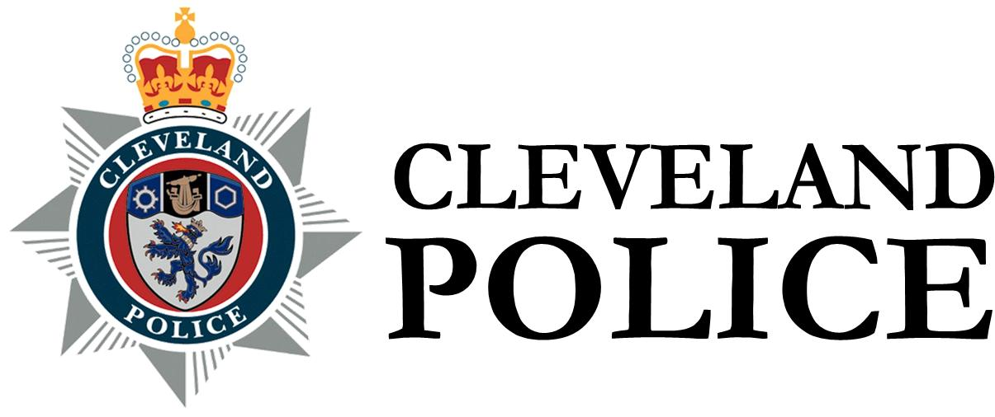 | Chief Constable for Cleveland  Audit of Accounts 2021/22  Notice of Completion of Audit of Accounts

Local Audit and Accountability Act 2014 and the Accounts and Audit Regulations 2015

Public notice is hereby given that under the Local Audit and Accountability Act 2014 and the Accounts and Audit regulations 2015, section 16, that the Audit of the Chief Constable for Cleveland’s Accounts for 2021/22 has completed and the Statement of Accounts is available for inspection by local government electors.

An unqualified opinion on the accounts and audit certificate was issued on 21 December 2023. On the same date, a commentary on the Value for Money (VFM) arrangements reported significant weakness and recommendation in relation to the VFM arrangements as required by the National Audit Office Code of Practice.

Any interested local government elector may request a copy of the accounts by writing to the Chief Finance Officer, Cleveland Police Headquarters, 1 Cliffland Way, Hemlington, Middlesbrough TS8 9GL, telephone (01642) 301903, e-mail ian.wright@cleveland.police.uk

Alternatively, copies of the accounts may be inspected during the hours of 10am to 4pm, by appointment at Cleveland Police Headquarters, 1 Cliffland Way, Hemlington, Middlesbrough TS8 9GL. This right is conferred on local government electors by section 25 of the Local Audit and Accountability Act 2014.

Dated 10 May 2024

Michael Porter
Chief Finance Officer and Deputy Chief Executive
Police and Crime Commissioner for Cleveland
Cleveland Police Headquarters
1 Cliffland Way
Hemlington
Middlesbrough
TS8 9GL

