Hartlepool Bleed Cabinets
Bleed Cabinet 1
Hartlepool Community Central Hub
124 York Road, Hartlepool, TS26 9DE
On front wall of building, left of entrance, next to existing Defibrillator cabinet.
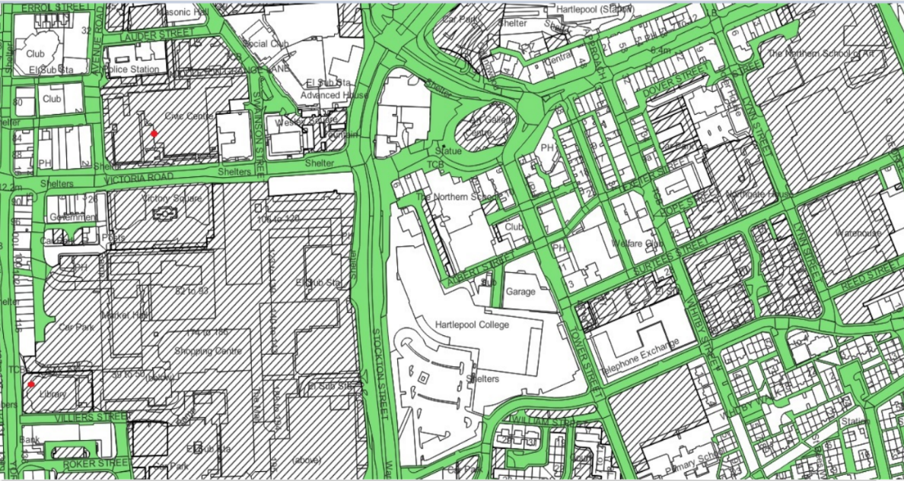
What3Words /// loser.report.dock

Bleed Cabinet 2
Hartlepool Borough Council
Civic Centre building, Victoria Road, Hartlepool, TS24 8AY
At front of building, at top of steps on front entrance concourse, next to existing Defibrillator cabinet.
What3Words /// handle.boot.twigs
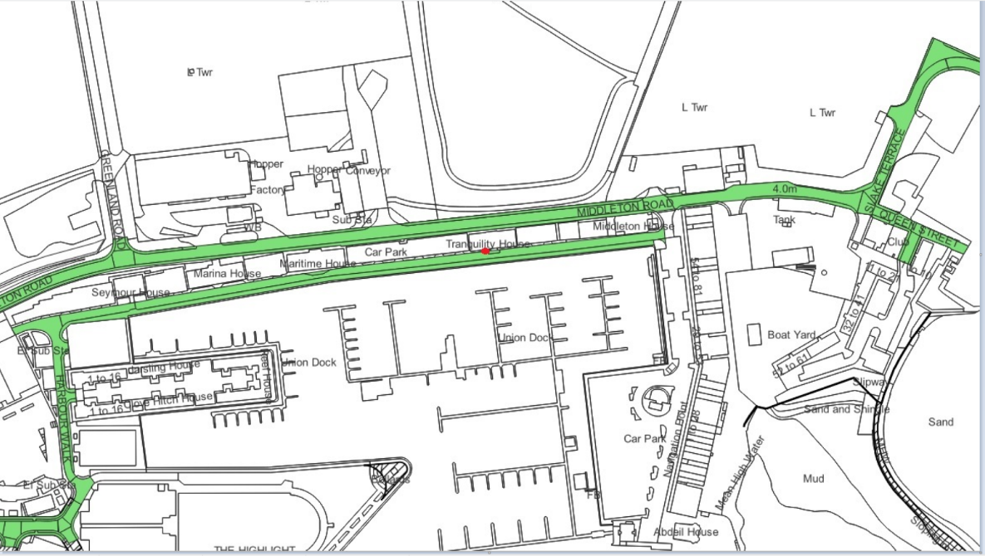

Bleed Cabinet 3
Tranquillity House (Orange Box building)
Harbour View, Hartlepool, TS24 0UX
Front wall of building, left of entrance, next to existing Defibrillator cabinet.
What3Words /// hype.occurs.nobody
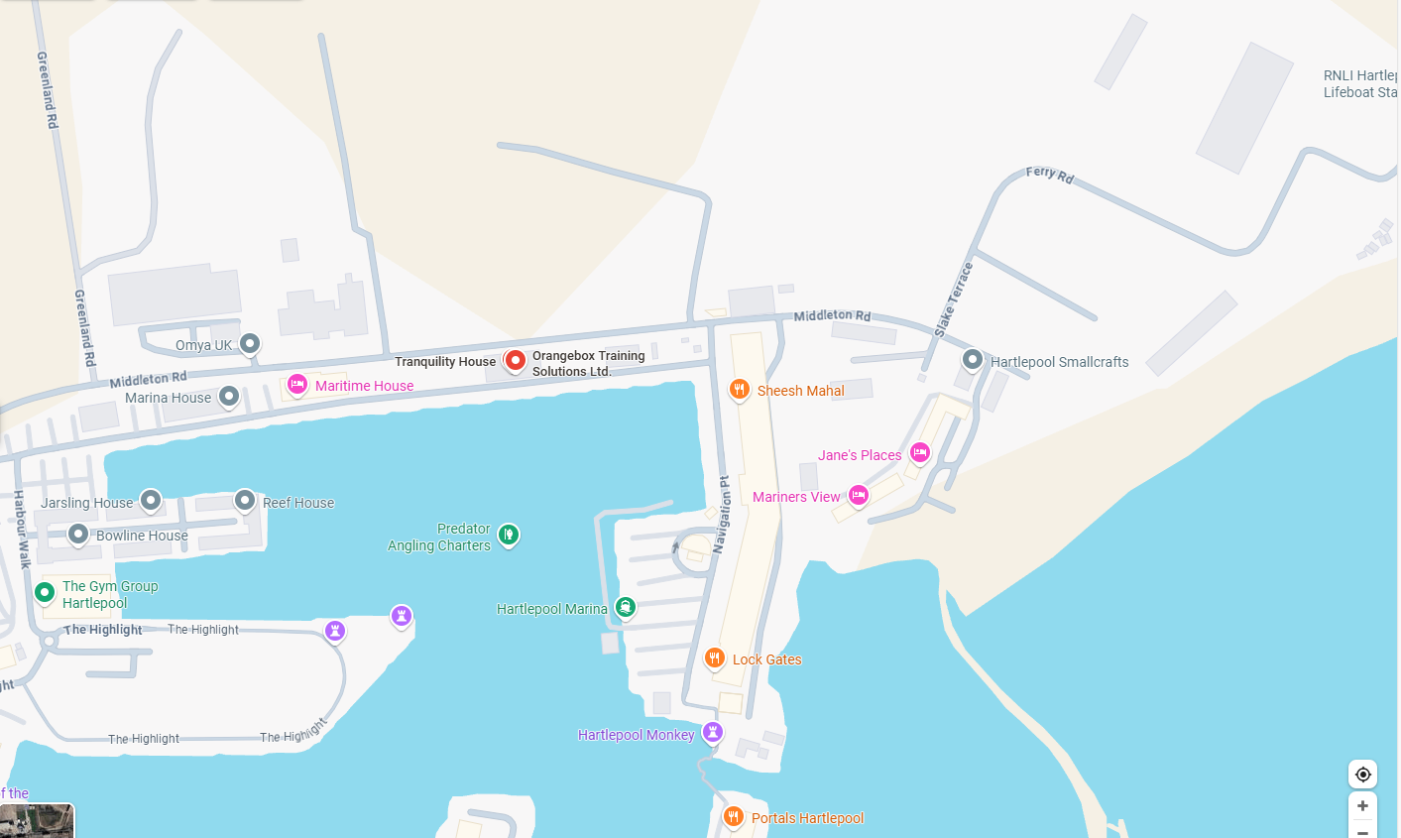

Bleed Cabinet 4
Hartlepool Railway Station
Station Approach, Hartlepool, TS24 7ED
On Council owned public space CCTV camera column, opposite front entrance of Hartlepool Railway Station, and opposite existing Defibrillator cabinet
What3Words location /// beats.vines.filer
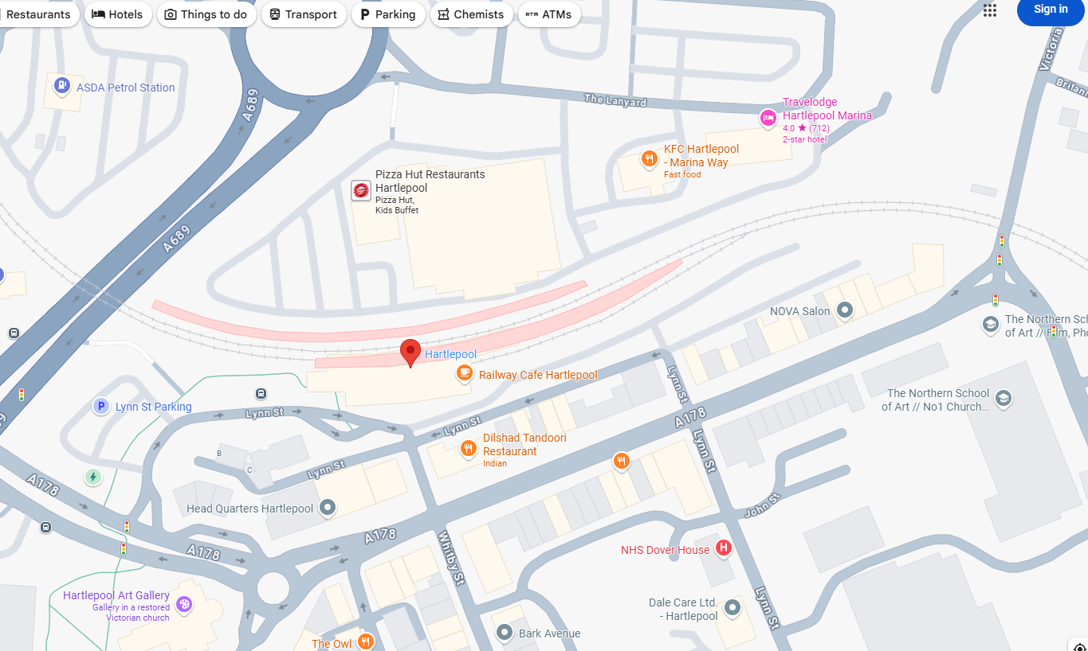

Bleed Cabinet 5
Salaam Community Centre
St Pauls Hall, Murray Street, Hartlepool, TS26 8PD
Front wall of building, right of entrance (combined Bleed Control Kit and Defibrillator cabinet)
What3Words location /// wedge.tanks.zest
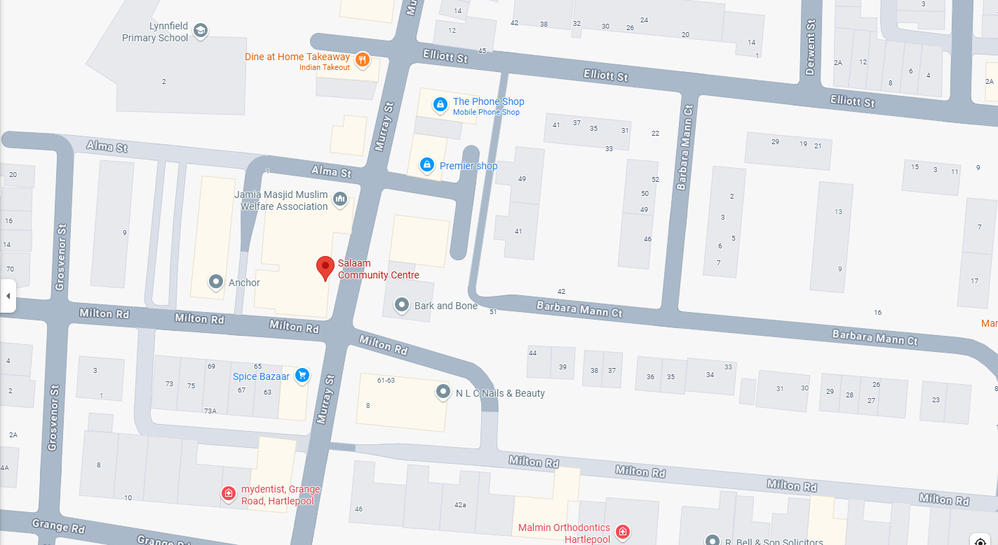

Bleed Cabinet 6
Hartlepool Police Station
Avenue Road, Hartlepool, TS24 8BB
Front wall of building on Avenue Road by fire exit
What3Words location /// casino.beam.office
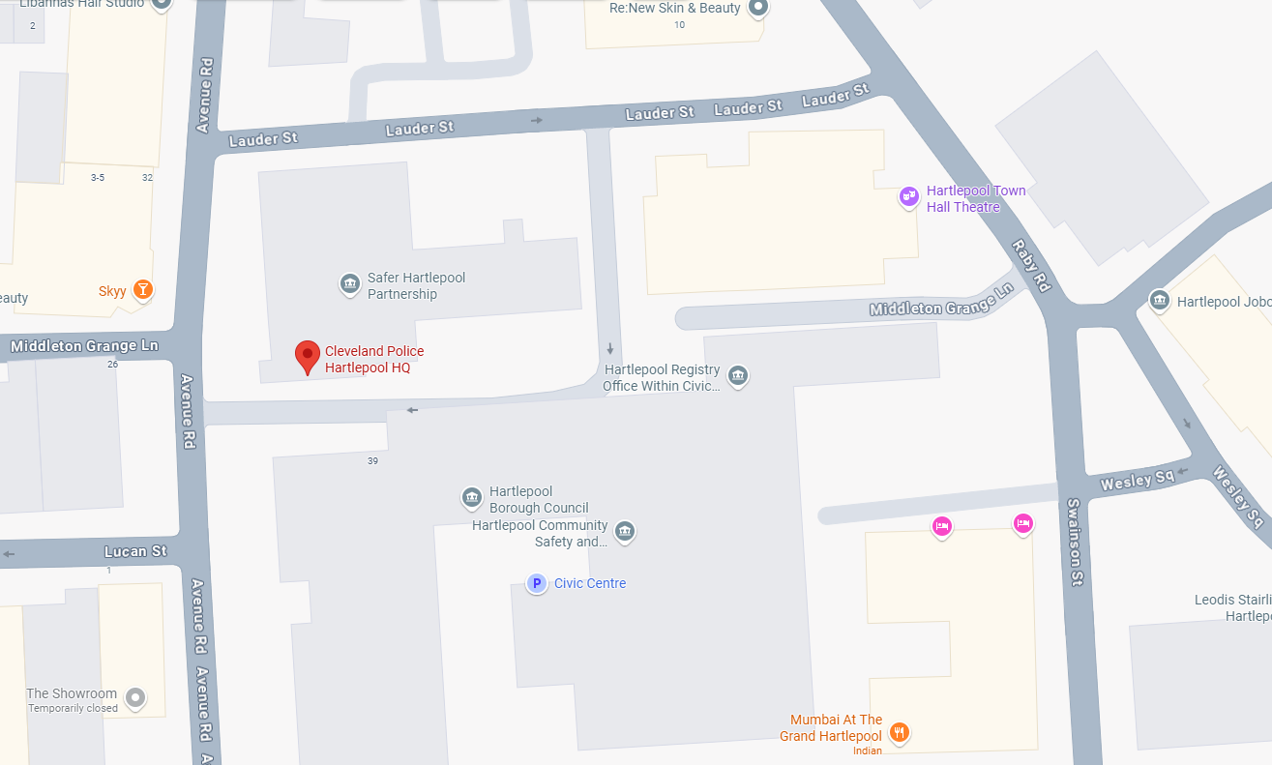

Bleed cabinet 7
Middleton Grange Shopping Centre
Victoria Road, Hartlepool TS24 7RZ
Top of steps at the Park Road Entrance to the Centre.
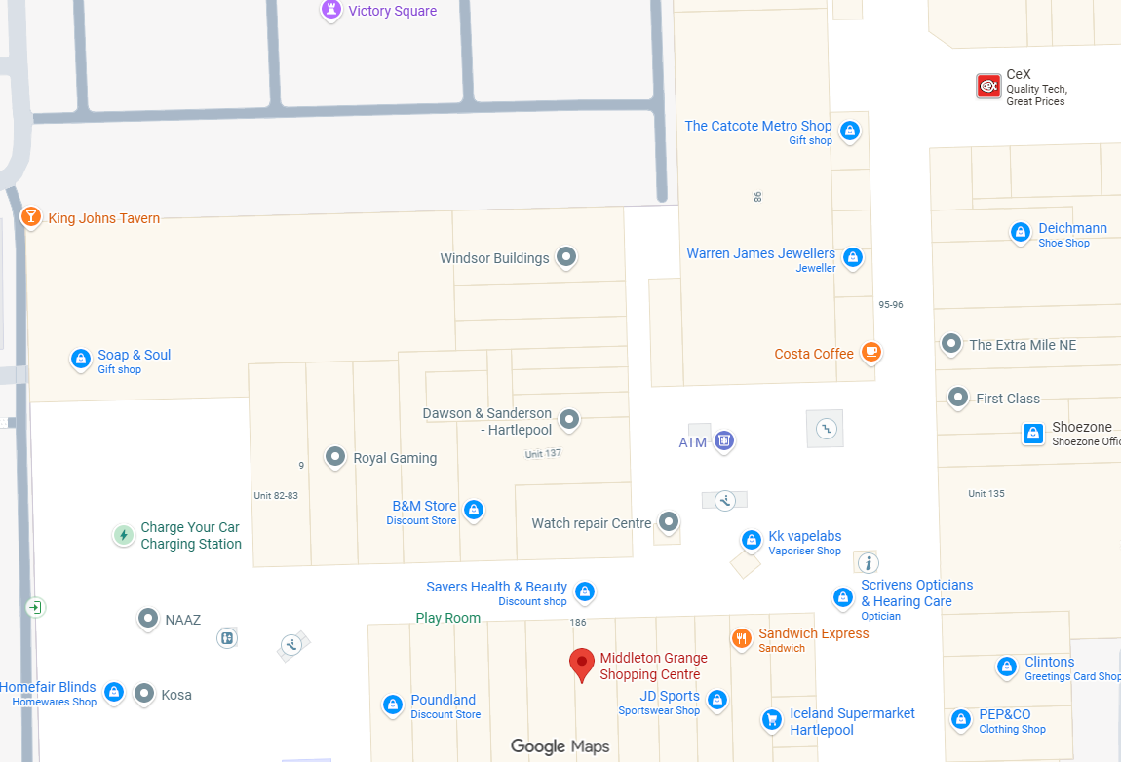

Stockton Bleed Cabinets
Bleed Cabinet 1
The Bank TS20.
53 Norton Rd, High St, Norton, Stockton-on-Tees TS20 1AJ
What3Words = forms.verge.shops
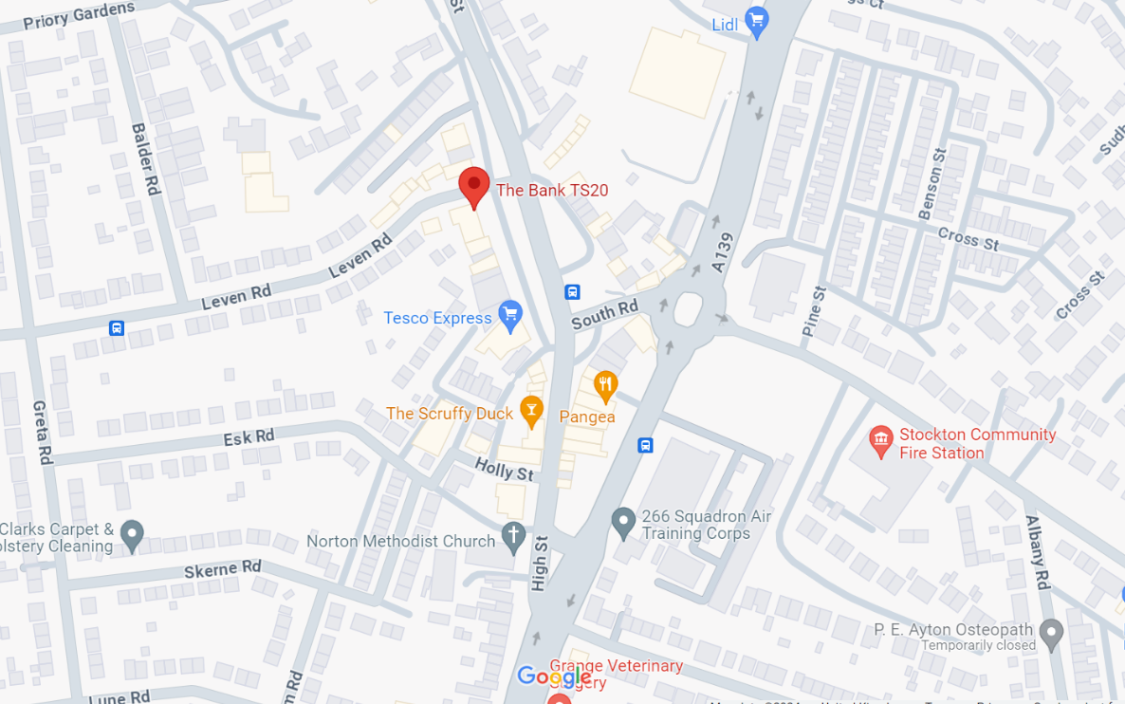

Bleed Cabinet 2
KU Stockton.
Prince Regent St, Stockton-on-Tees TS18 1DB
Attached to outside of building, near entrance to club.
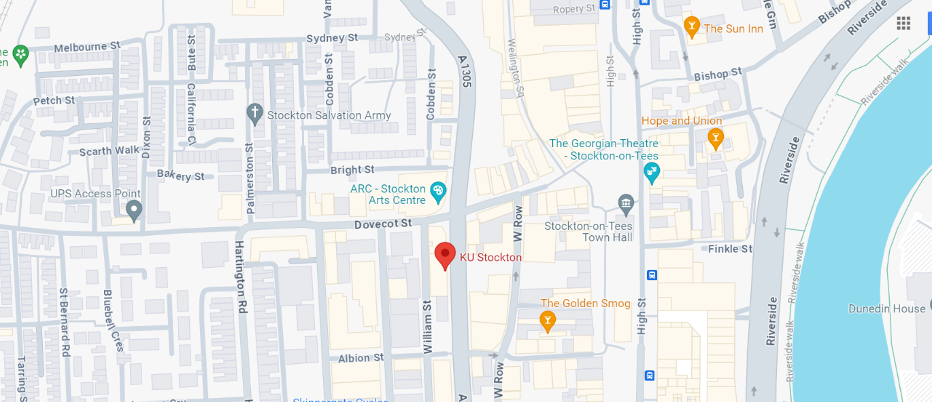
What3Words = design.ladder.cemented

Bleed Cabinet 3
The Shambles.
High Street, Stockton-on-Tees, TS18 1AU
Attached to a light column outside.
What3Words = procured.penned.heightens
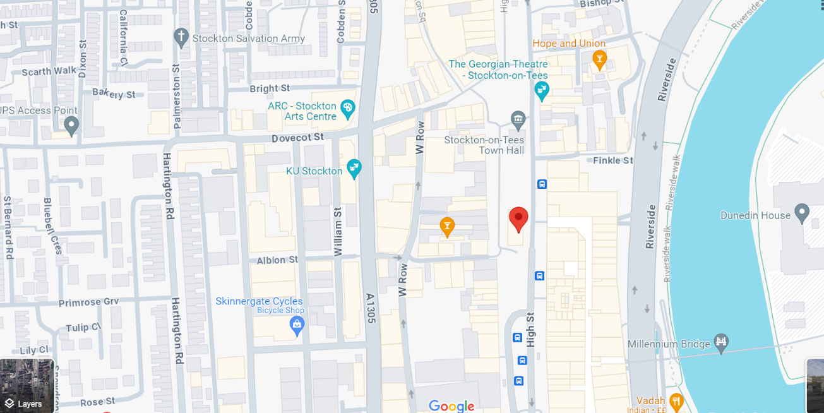

Bleed Cabinet 4
Yarm Town Hall.
High Street, Yarm, TS15 9AH
Attached to the outside of the building.
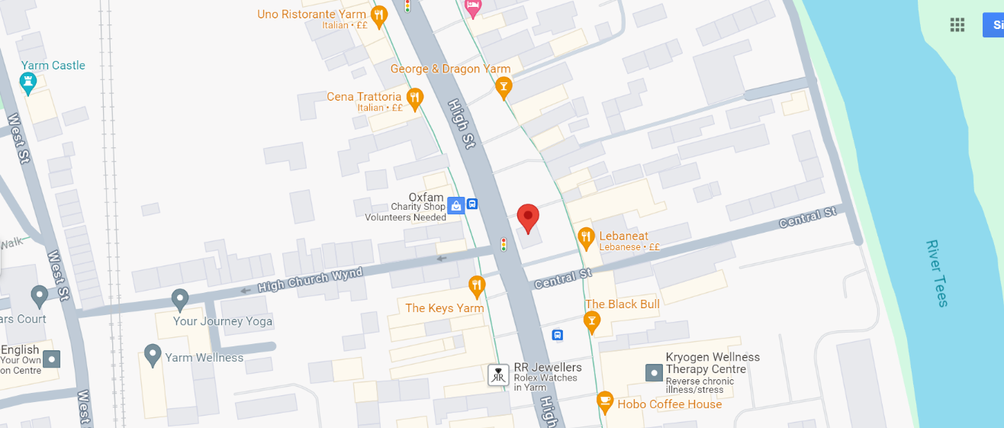
What3Words = iterative.wants.division

Bleed Cabinet 5
Stockton Police Station
Thistle Green
Stockton-on-Tees
TS18 1TZ
Located at entrance to the building.
What3Words = ///consoled.easels.dignity
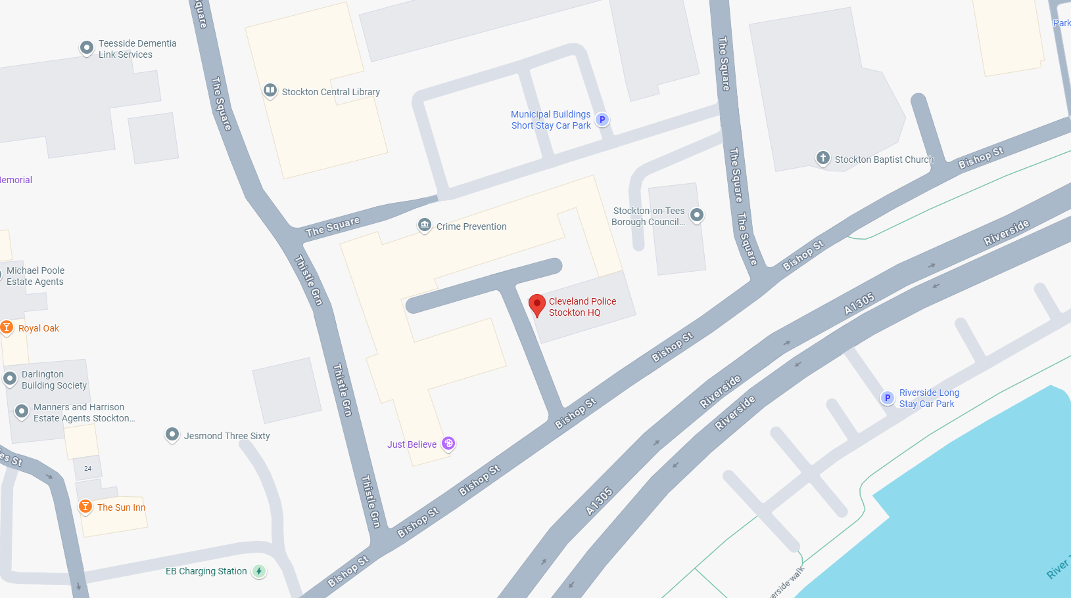

Bleed Cabinet 6
St Marks House
St Mark's Ct, Thornaby, Stockton-on-Tees TS17 6QW
Located at entrance.
What3Words = ///florists.moral.button
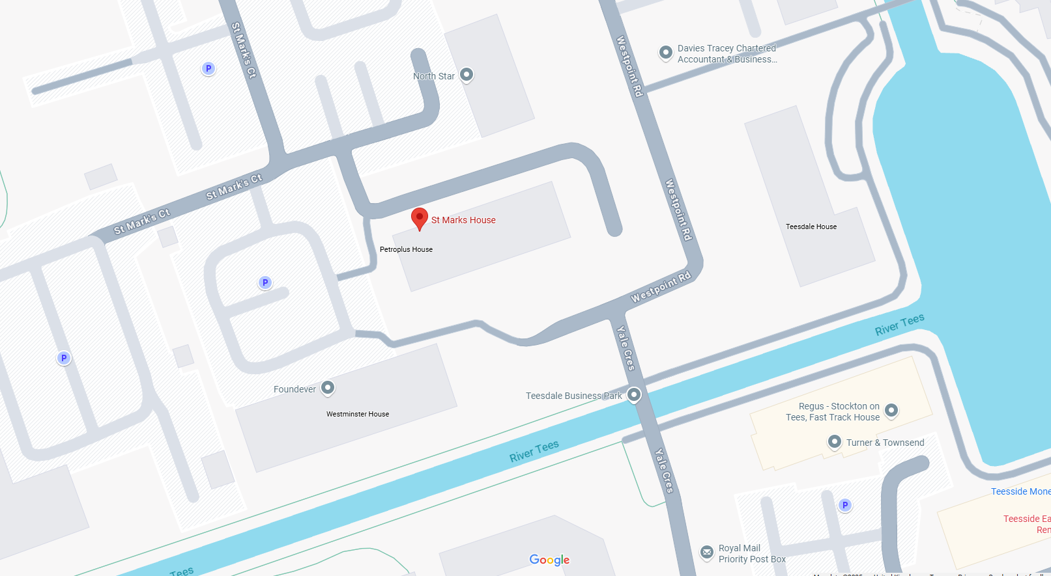
Bleed Cabinet 7
Billingham Forum
Entrance
The Causeway, Stockton-on-Tees, Billingham TS23 2LJ
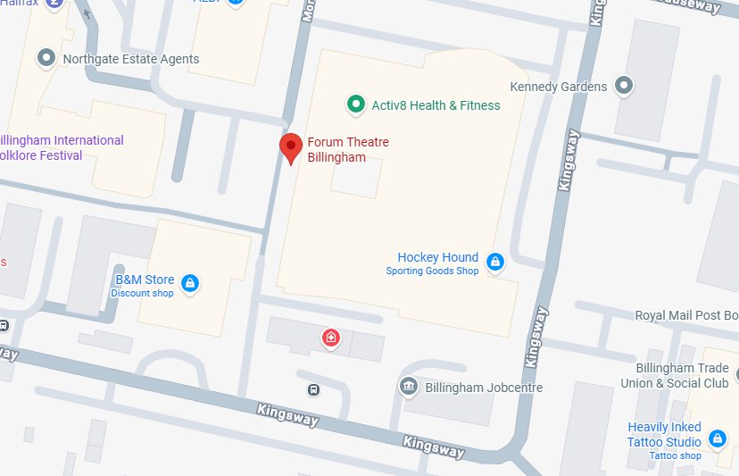
Bleed Cabinet 8
IB Leisure
Entrance
IB Leisure, Blair Ave, Thornaby, Stockton-on-Tees TS17 5BL
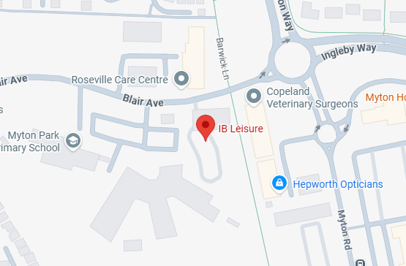
Bleed Cabinet 9
The Top House (Unicorn)
Entrance
147 High St, Norton, Stockton-on-Tees TS20 1AA
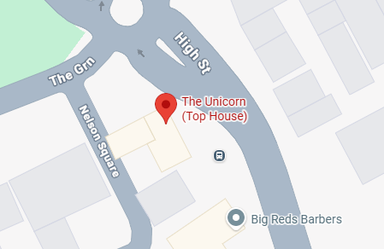

Bleed Cabinet 10
Castle and Anchor
Entrance
2 Church Rd, Stockton-on-Tees TS18 1TY
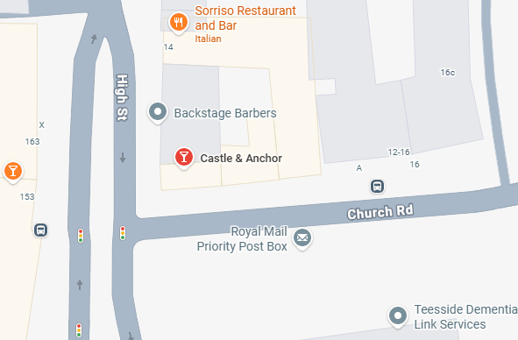
Bleed Cabinet 11
Teesside Park
Retail Park South Corner of TK Maxx and Curry’s
Unit 3, Teesside Retail Park, Thornaby Road, Thornaby, Stockton-on-Tees TS17 7BW

Bleed Cabinet 12
Teesside Park
Retail Park North Corner of sub station opposite 5 guys
Haydock Pk Rd, Thornaby, Stockton-on-Tees TS17 7BG

Bleed Cabinet 13
Teesside Park
Leisure park, front tower in front of Pizza Hut
Teesside Leisure Park, Aintree Oval, Thornaby, Stockton-on-Tees TS17 7BU

Bleed Cabinets in Redcar
Bleed Cabinet 1
Cygnet Lawyers.
54 Station Rd, Redcar TS10 1AG
On the Corner of Queen street/Station Road.
What3Words = wiser.bleat.judges
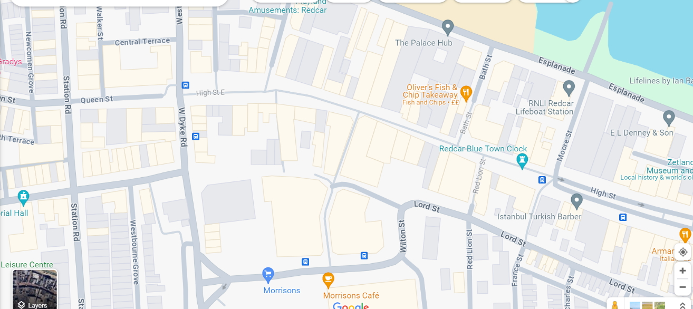

Bleed Cabinet 2
Darlington Building Society.
Unit 1 Regent Walk, Redcar TS10 3FB
What3Words = harsh.crush.first
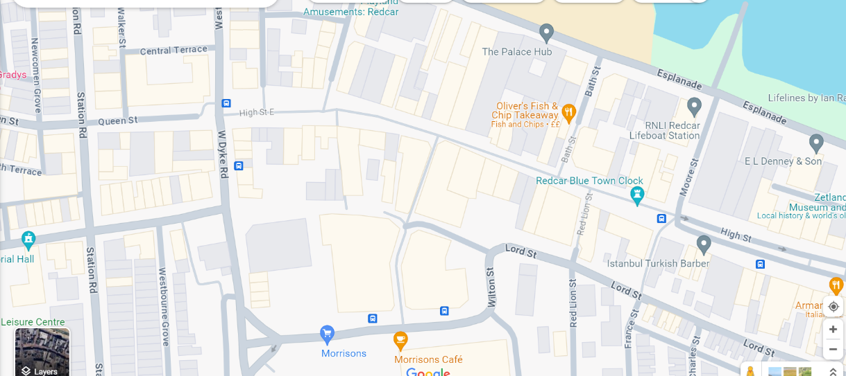

Bleed Cabinet 3
Kidney Research UK.
102-108 High St, Redcar TS10 3DD
What3Words = boat.neck.thus
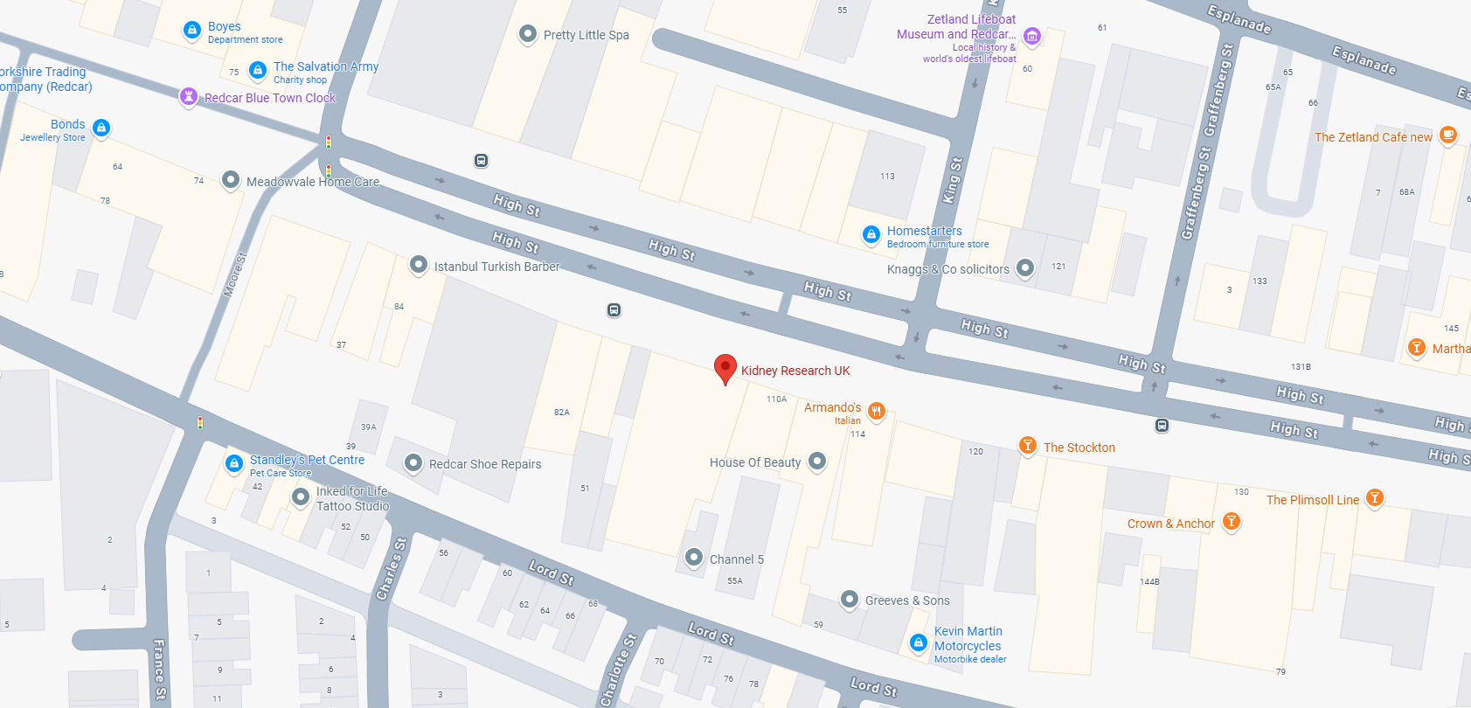

Bleed Cabinet 4
Scott’s Chemist.
3, Roseberry Shopping Centre, Roseberry Rd, Redcar TS10 4NY
What3Words = scam.basket.parks
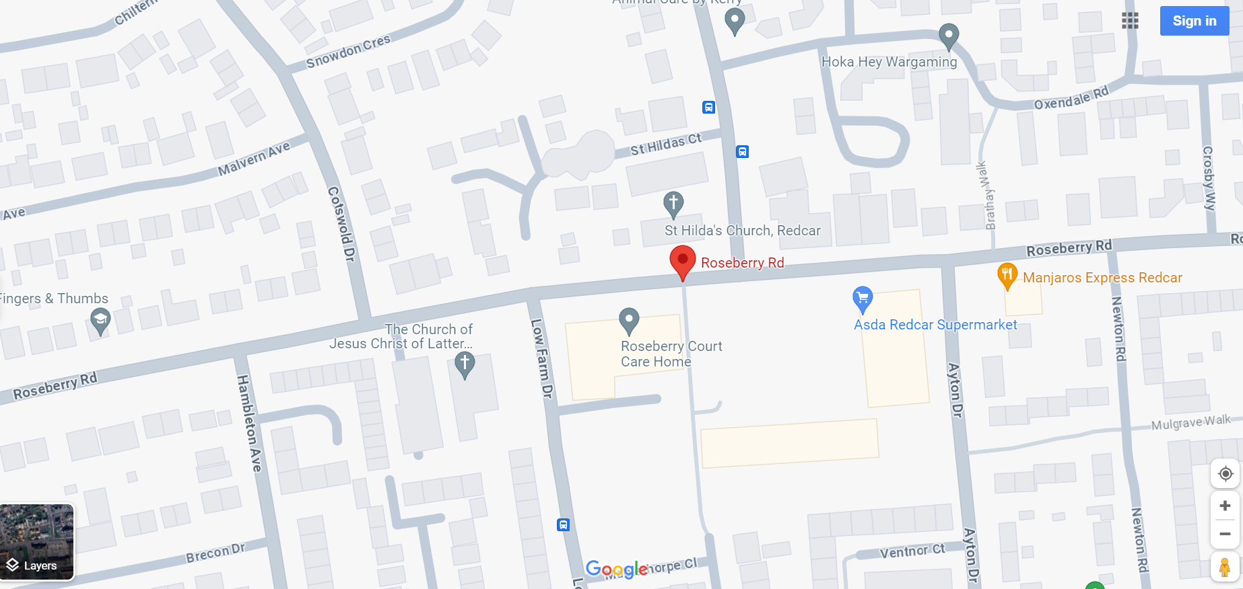

Bleed Cabinet 5
Ennis Square Social Club.
The Royal British Legion, 12 Ennis Rd, Redcar TS10 5JR
What3Words = words.store.shots
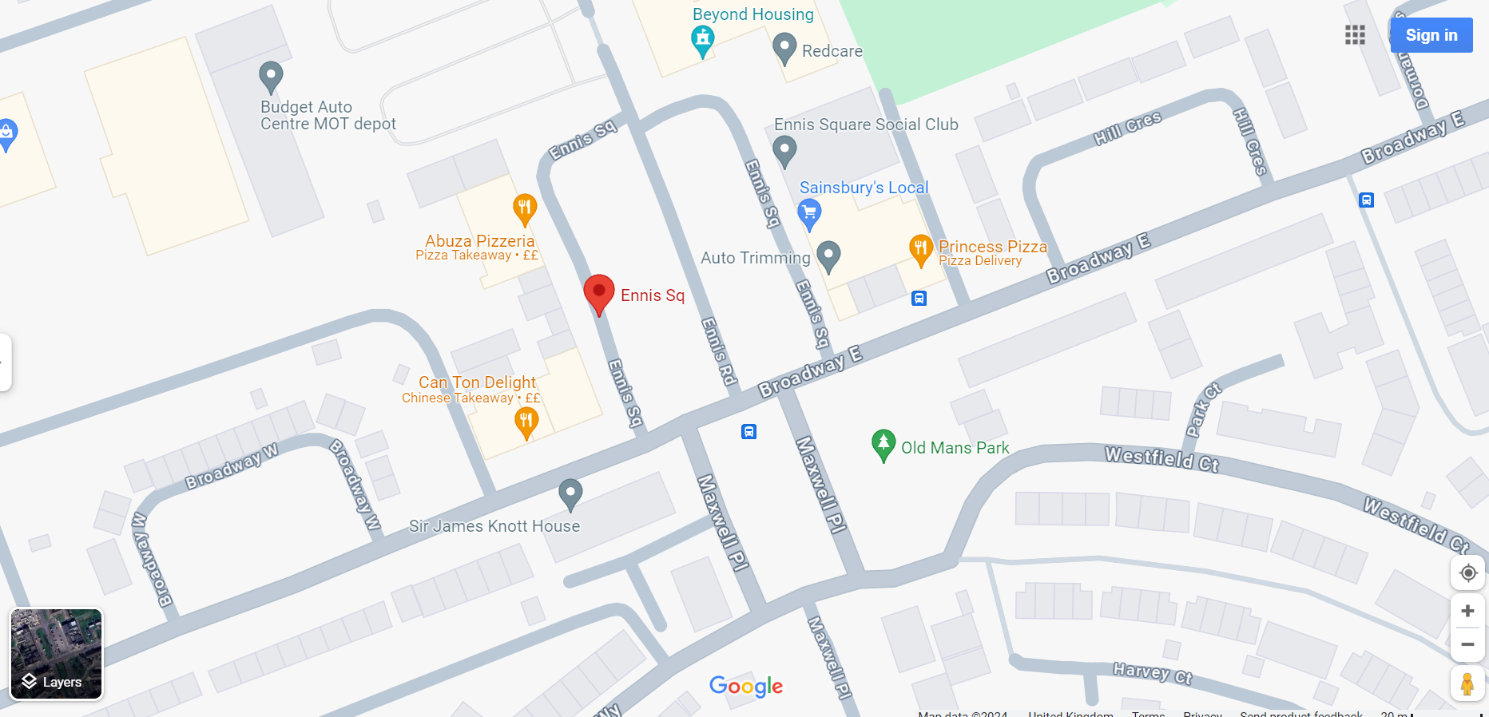

Bleed Cabinet 5
Ennis Square Social Club.
The Royal British Legion, 12 Ennis Rd, Redcar TS10 5JR
What3Words = words.store.shots
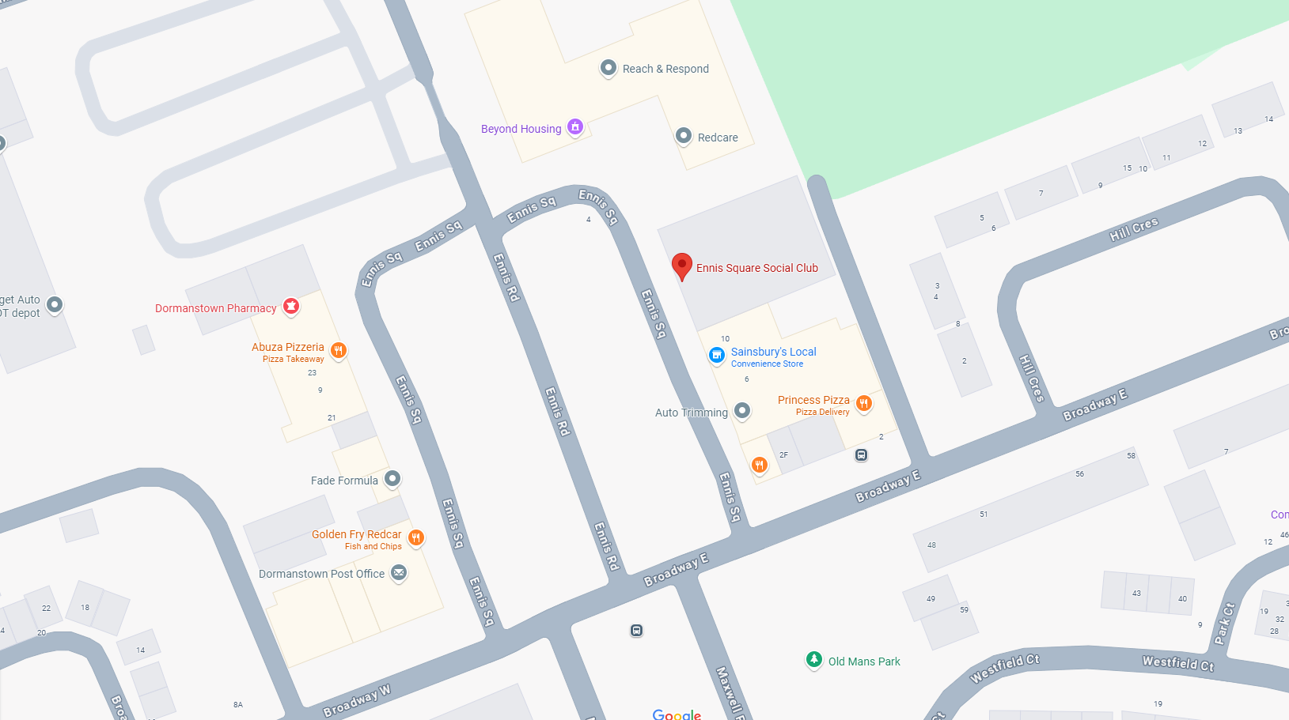

Bleed Cabinet 6
Eston Police Station
High St, Eston, Middlesbrough TS6 9JF
What3Words = ///salon.rival.dome
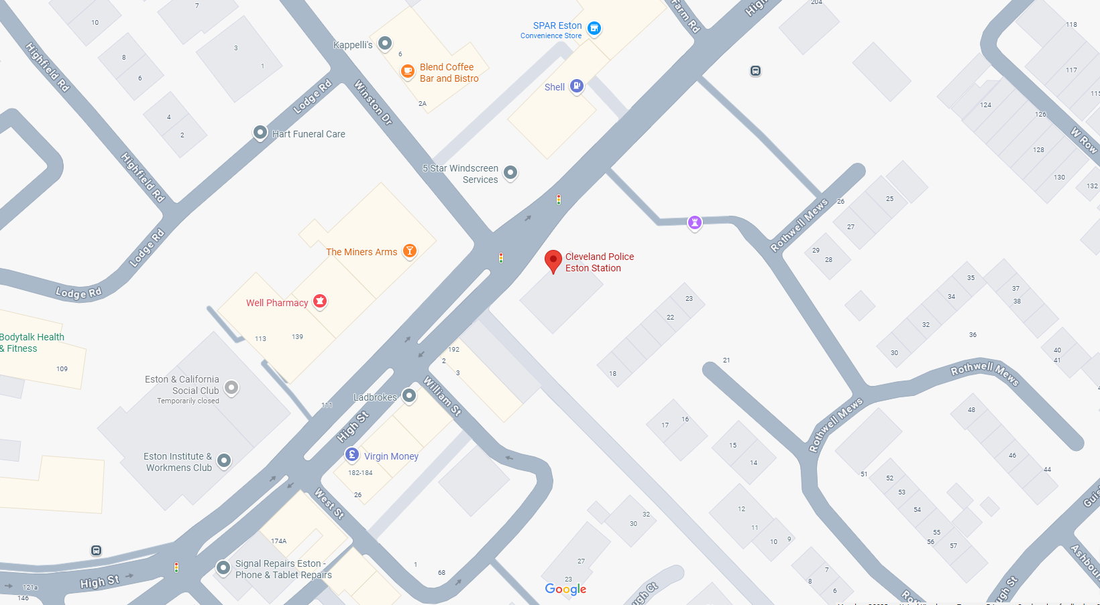

Bleed Cabinet 7
Kirkleatham Police Station
Troisdorf Way
Redcar
TS10 5AP
What3Words = ///pokers.formal.paints
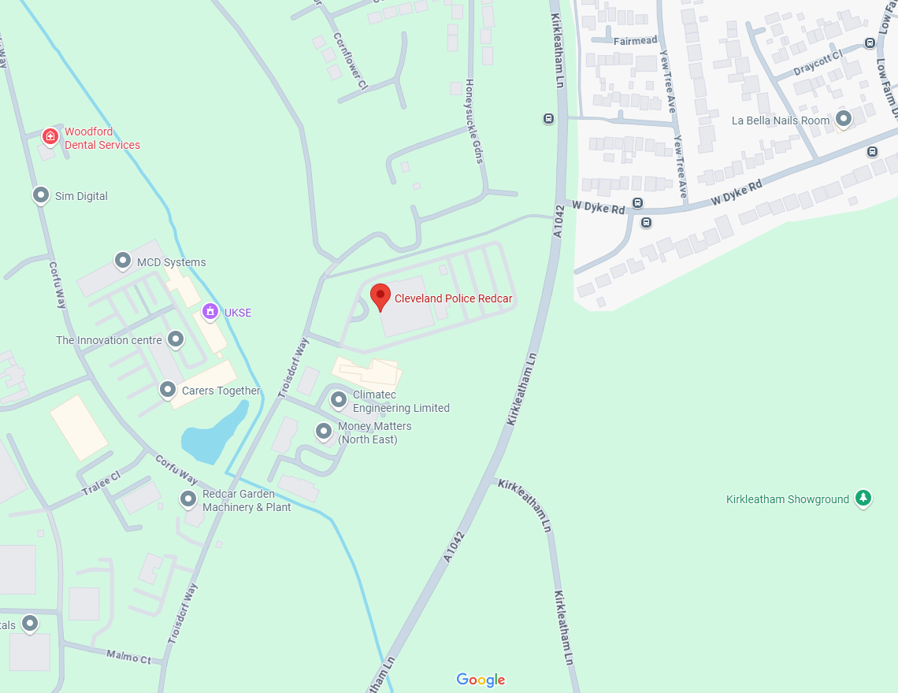

Bleed Cabinet 8
Guisborough Police Station
Church Ln, Guisborough TS14 6RB
What3Words = ///magpie.processes.clusters
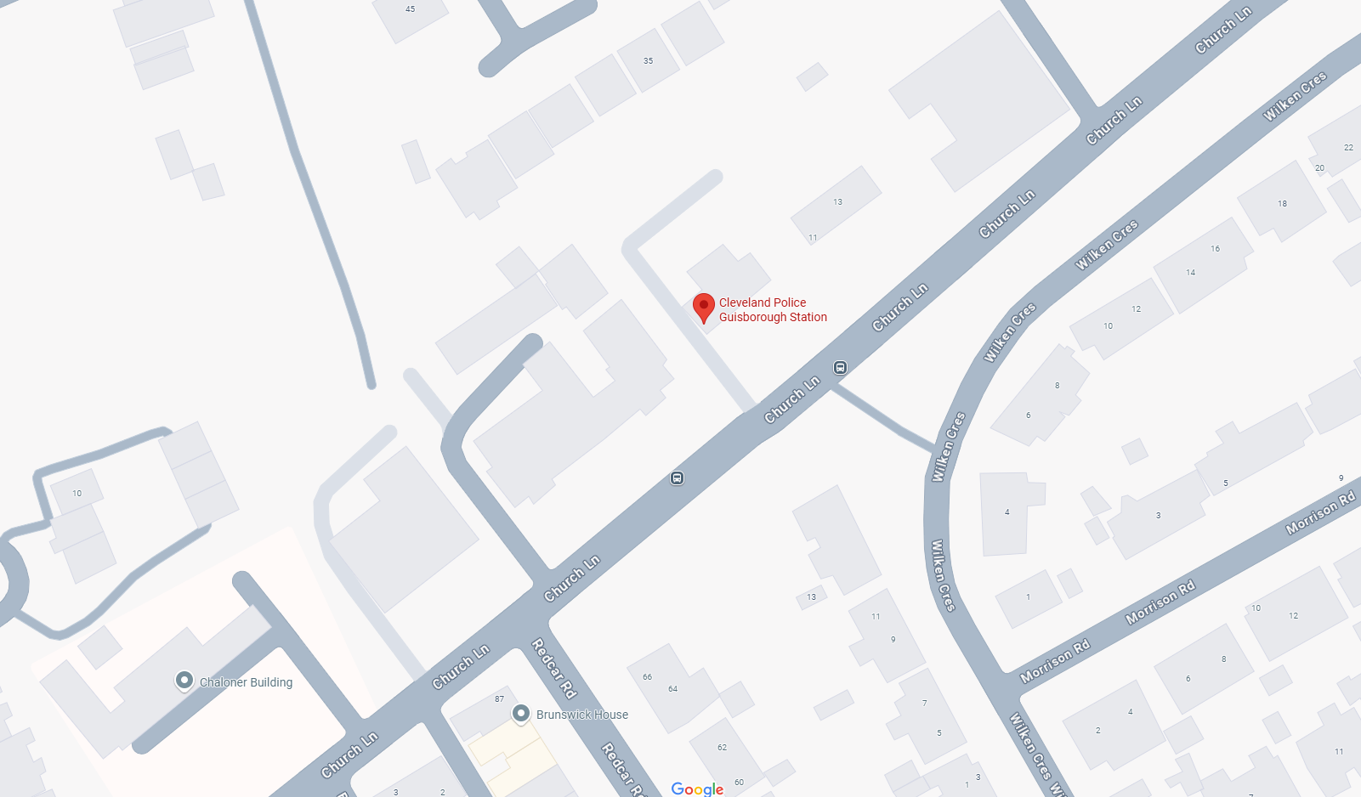

Bleed Cabinet 9
Asda Skelton
Entrance
Pheasant Fields Ln, Skelton-in-Cleveland, Saltburn-by-the-Sea TS12 2ZL
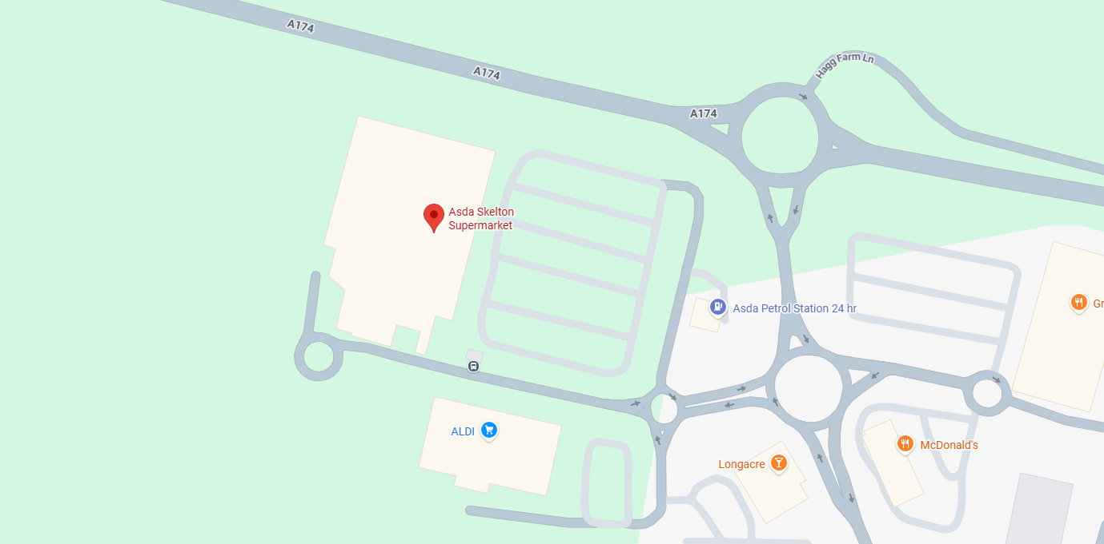

Bleed Cabinet 10
Pump Station Skinningrove
Northern end of Marine. It is situated next to the Skinningrove Jetty Car Park
Terrace, Skinningrove, with the postcode TS13 4BJ.
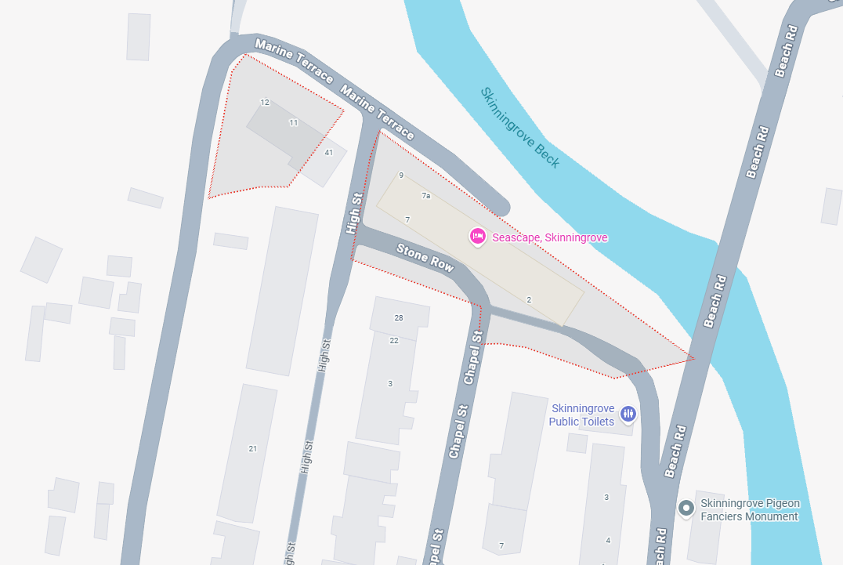

Bleed Cabinet 11
Loftus Police Station
Entrance
Police Station, West Road, Loftus, Saltburn-by-the-Sea TS13 4RJ
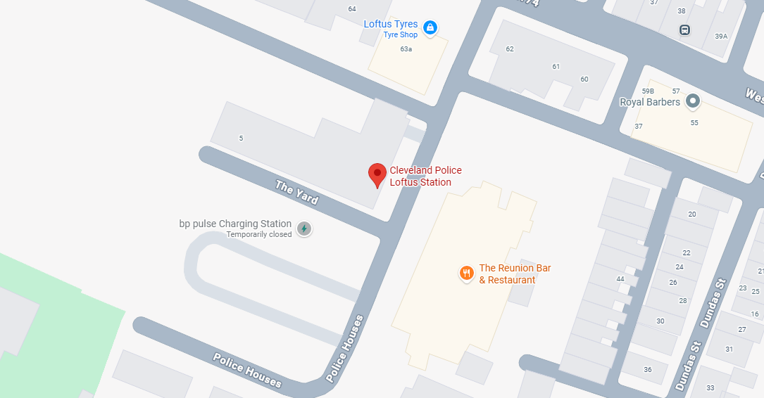
Bleed Cabinet 12
Saltburn Police Station
Entrance
Police Station, 29 Windsor Road, Saltburn-by-the-Sea TS12 1AX
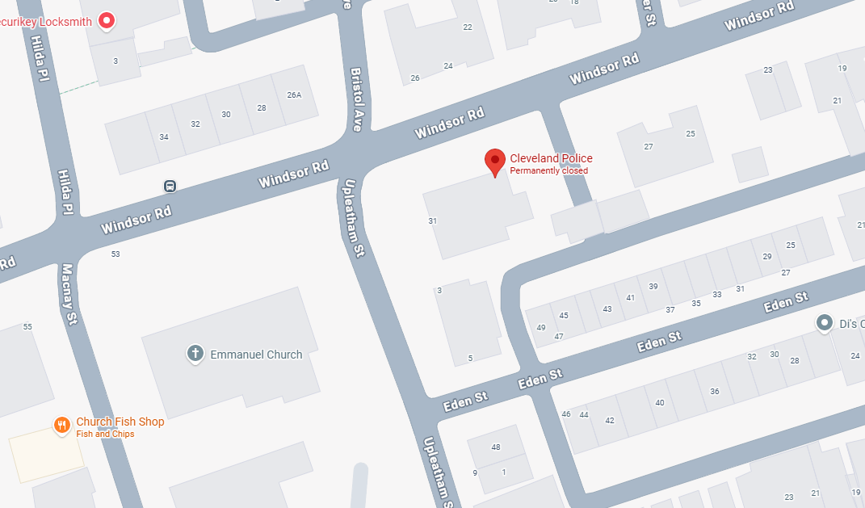

Middlesbrough Bleed Cabinets
Bleed Cabinet 1
Albert Road
Opposite Boro Bar and between Vape and furniture store
52, Albert Road, Middlesbrough, TS1 1QD
What3Words = print.passes.ruby
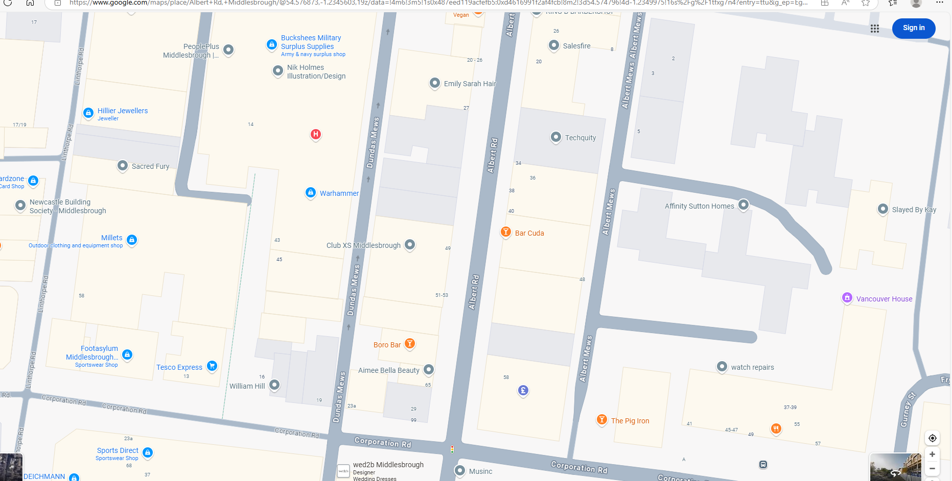
Bleed Cabinet 2
Central Point Business Centre (Corner of Oven Restaurant)
202-206 Linthorpe Rd, Middlesbrough TS1 3QW
What3Words = melt.laptop.parade
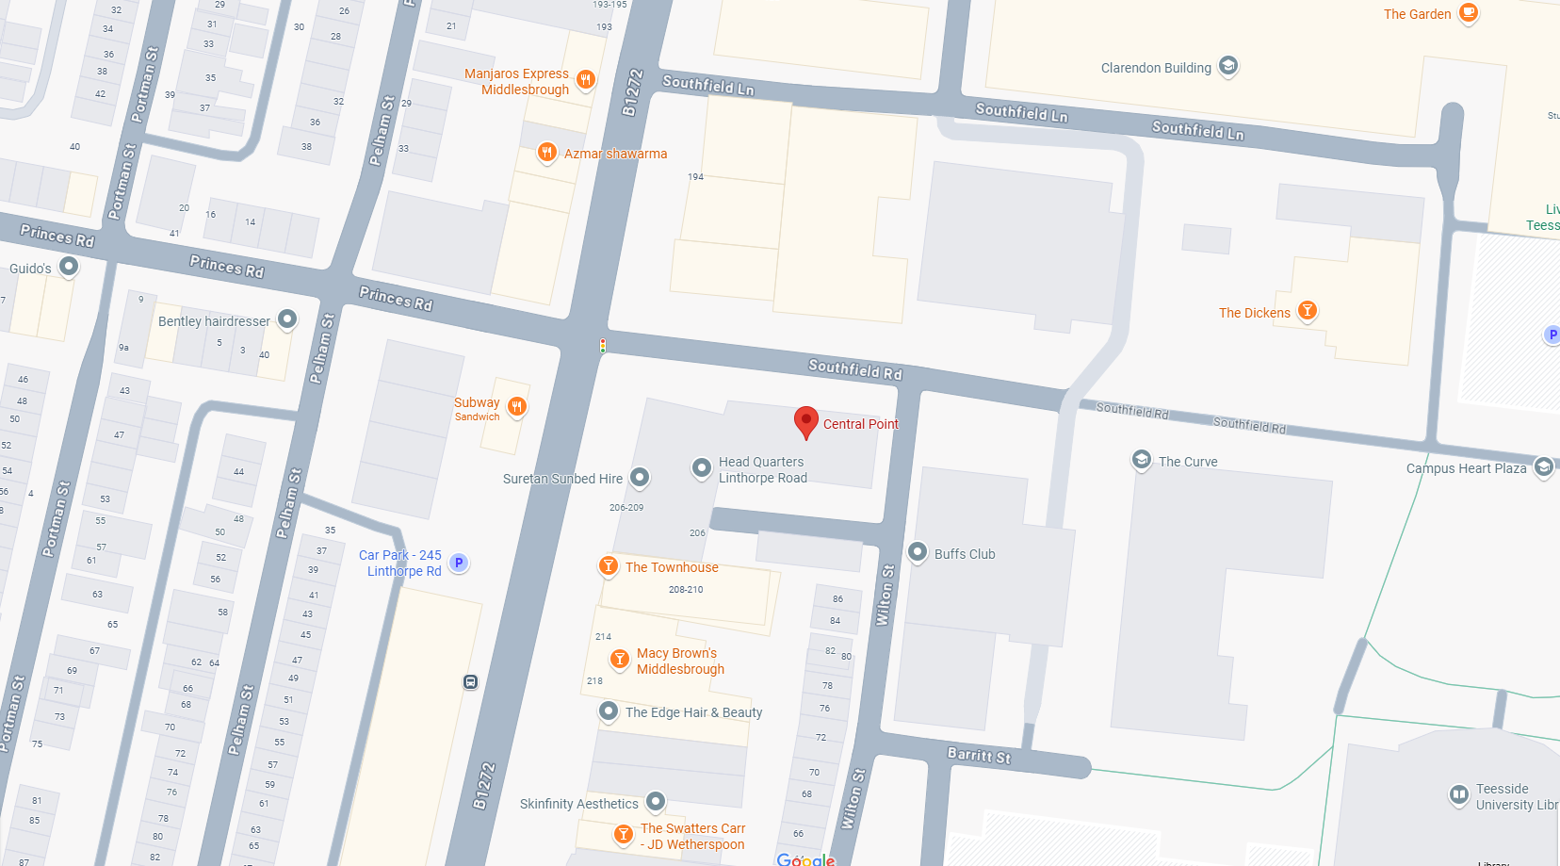

Bleed Cabinet 3
Tesco Express External Wall.
14 Corporation Rd, Middlesbrough TS1 1LJ
What3Words = rainy.orbit.change
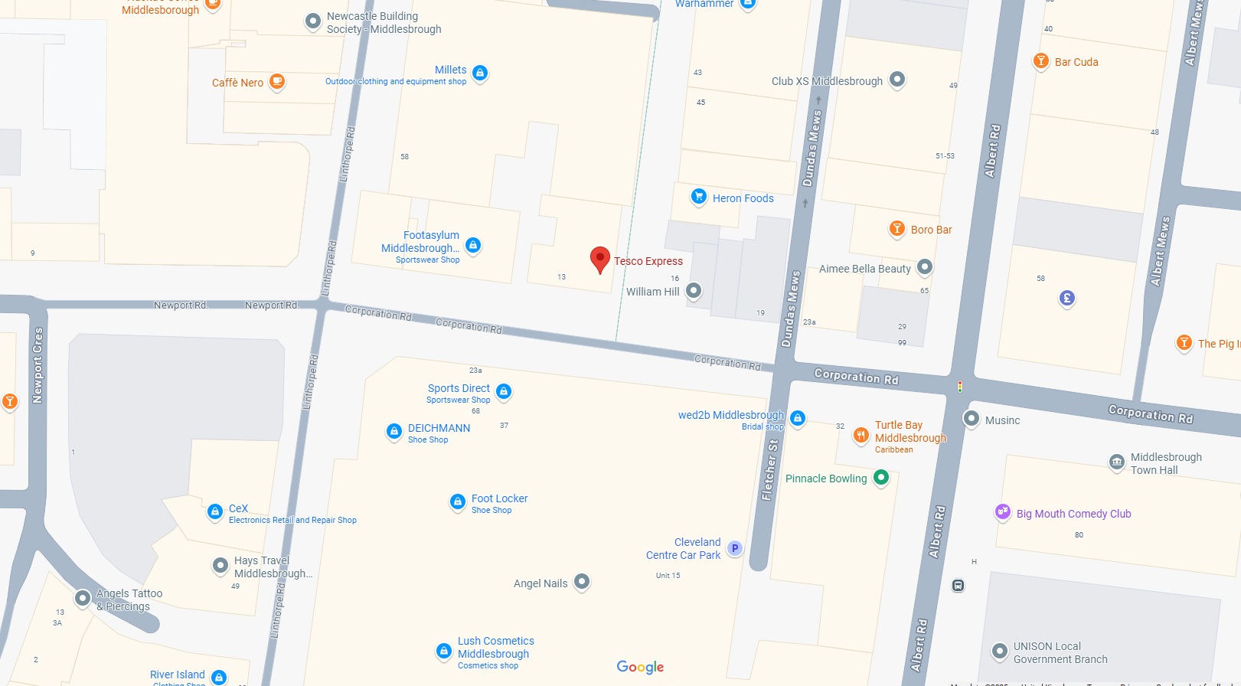

Bleed Cabinet 4
Next to The Entertainer Shop Captain Cook Square (old TK Maxx building)
Unit 2, 13 Captain Cook Square, Middlesbrough TS1 5UB
What3Words = tilt.darker.shades
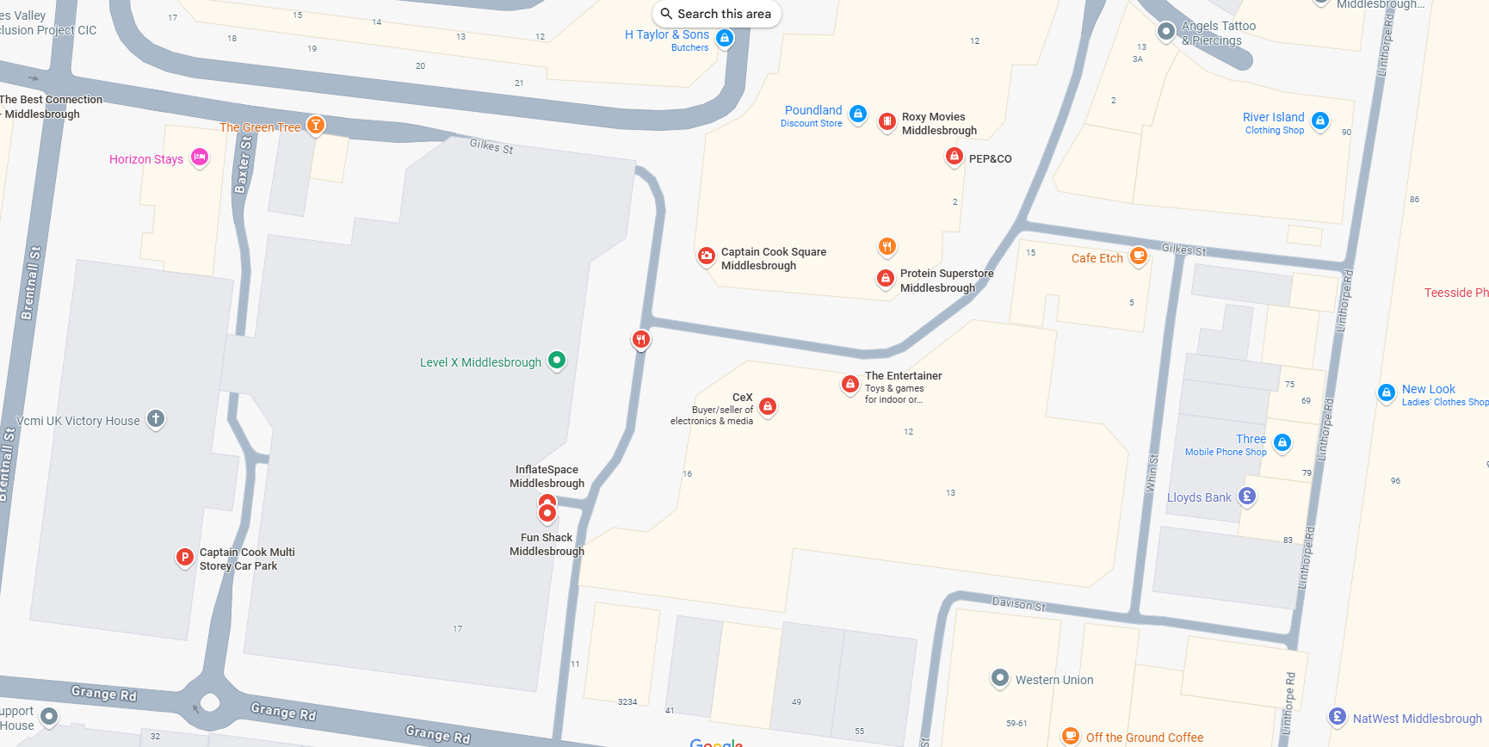

Bleed Cabinet 5
M8
At the entrance next to the defib.
Bridge St W, Middlesbrough TS2 1AB
What3Words = ///freed.clocks.tubes
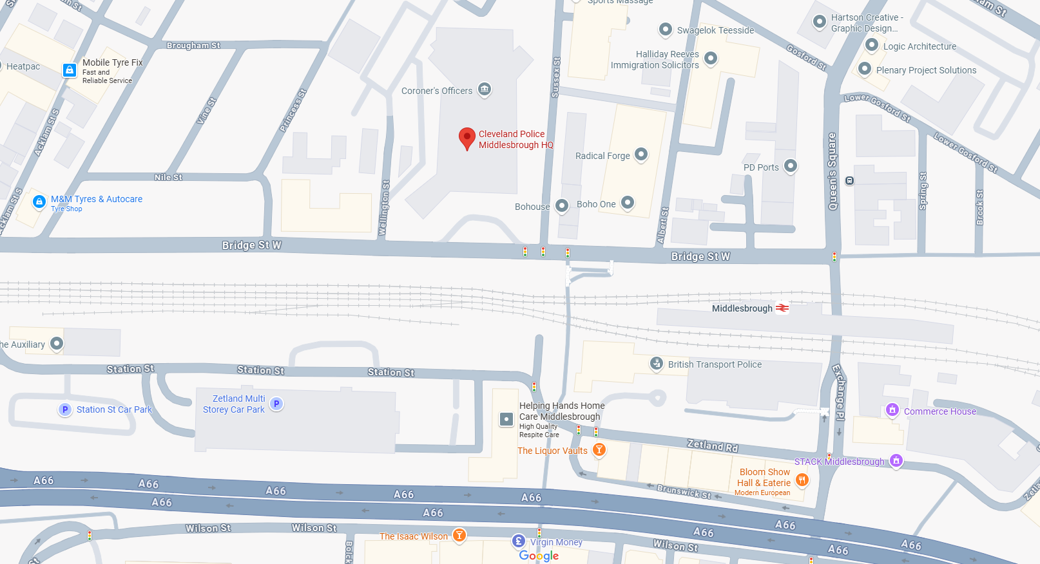

Bleed Cabinet 6
Hemlington HQ
At the visitor's entrance, next to the defib.
1 Cliffland Way, Middlesbrough TS8 9LB
What3Words = ///melts.silk.allowable
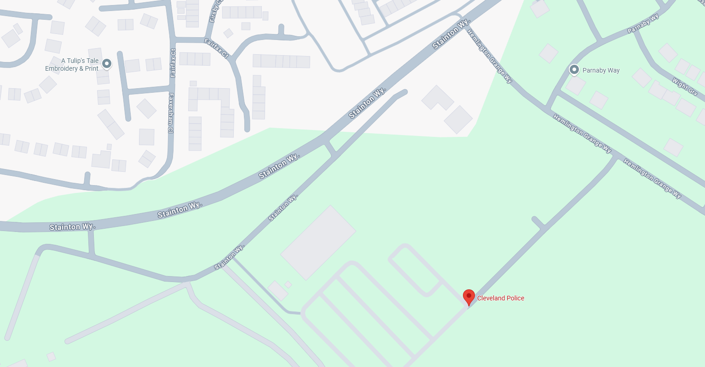

Bleed Cabinet 7
Hillstreet Shopping Centre
Management Office
Hillstreet
Middlesbrough
TS1 1SU
Entrance opposite the Bus Station (Newport Road)
Located to the right on Hill Street
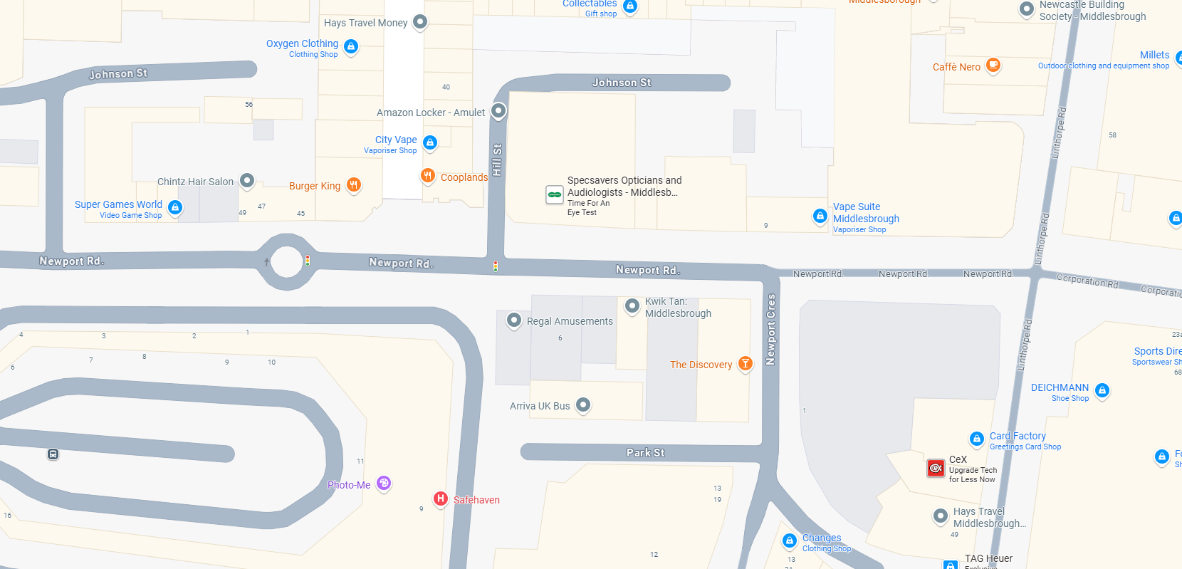

Bleed Cabinet 8
Cleveland Centre
Grange Road Entrance.
85 Grange Rd, Middlesbrough TS1 2LS
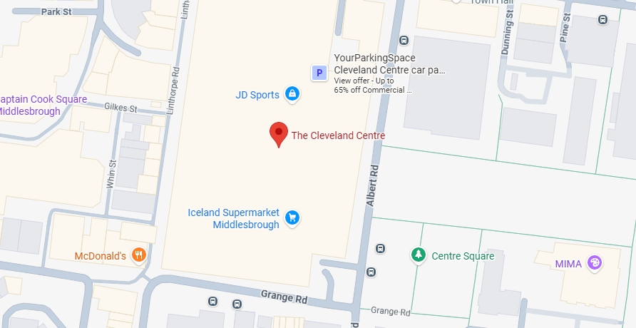
Bleed Cabinet 9
Live Well Centre
Entrance
Located on Albert Road next to main live well centre doors, opposite the fountains in centre
square.
Cleveland Centre, 103 Albert Rd, Square, Middlesbrough TS1 2PA
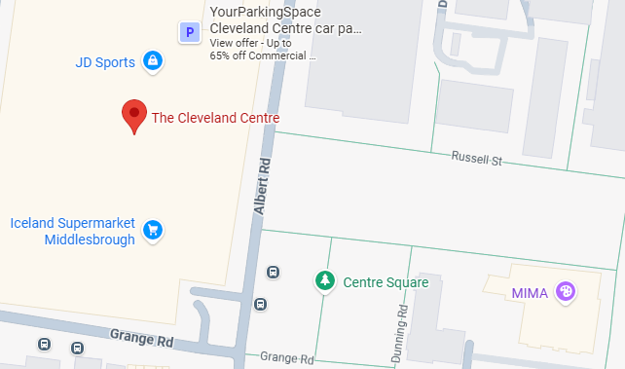

Bleed Cabinet 10
Live Well Centre
Entrance
Located on the main pedestrian concourse attached to live well East building next to the front main entrance opposite Crossfell Health Centre GP's
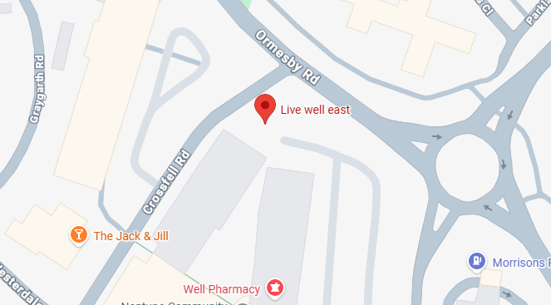
Bleed Cabinet 11
Riverside Stadium
Right hand side of the fanzone bar – just under the stairs.
Middlehaven Way, Middlesbrough, TS3 6RS
what3words – kings:flown:backed
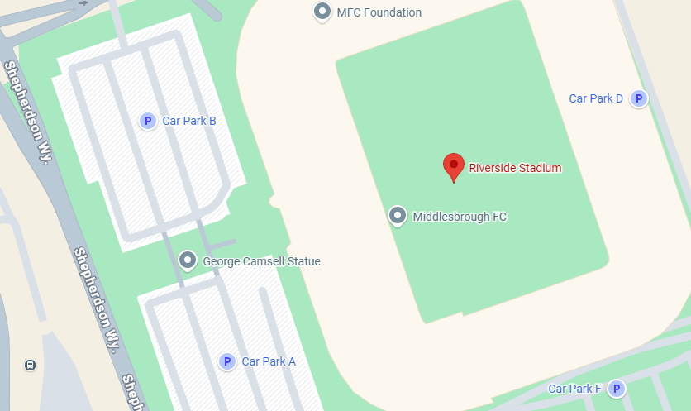
Bleed Cabinet 12
Mcdonalds
Located on the wall next to McDonalds back gate, Davison Street.
95 Linthorpe Rd, Middlesbrough TS1 5DD

